PROJECT OVERVIEW

General information:

Project’s Title: | Recovery of tarwi (Lupinus Mutabilis S.) seeds in four communities of the Carabuco Municipality that surrounds the Titicaca Lake.
Project’s Site: | Communities: Huajasiya, Cacachi, Cavinchilla, Tilacoca and Cojatapampa of the Carabuco Canton, in the Municipality of Carabuco, Camacho Province of the de la Paz Department in Bolivia.
Promoter(s): | Cuna Association (Cradle Association)  Estados Unidos Street n°1487, crossing with Puerto Príncipe, Miraflores Zone, mpolo@cuna.org.bo, telf-fax 2112380, contact: José Villarroel, Marco Polo
Project’s Partners: | Inhabitants of the communities involved in the Project.  Municipal Government of Carabuco.
Project’s total cost: | 71.500 US dollars
Amount requested for financing: | 35.000 US dollars; cash
Local counterpart: | 6.500 US dollars, in kind and labor
Other co-financing: | 30.000 US dollars in cash and labor (Cuna Association)
Duration of the project: | 24 months

Project’s Description

OBJECTIVE

The project aims at the recovery of the tarwi seed (lupinus mutabilis) in four communities of the Carabuco Municipality that surrounds the Titicaca Lake, in order to increase the production of tarwi crops through the use of certified seeds, as a measure for the adaptation to climate change and a way to reduce the inhabitants’ vulnerability.

DESCRIPTION OF THE COMMUNITIES INVOLVED

The Municipality of Carabuco is located south of the 15º 34’ 58’’ latitude and west of the 68º 55’ 30’’ longitude, and is under the jurisdiction of the Third Municipal Section of the Camacho Province in the La Paz Departement. It can be reached through the La Paz-Puerto Acosta road, and it is located in an heterogeneous geographical zone: altitudes go from 3,820 to 4,482 meters above the sea level, and the capital is located at an altitude of 4,100 meters above the sea level. It has a territorial extension of 1.686.64Km² , 375.4 Km² (22%) of which correspond to the Carabuco Cantón and 504.61 Km² (30%) to the Chaguaya Cantón. Both cantons have a population of 2,903 and 4,597 inhabitants respectively; the communities of Huajacia, Cavinchilla and Cacachi correspond to the Carabuco Canton, while the Tilacoca and Cojata Pampa ones correspond to Chaguaya; they are both located north of the Plateau of the La Paz Departement and this region corresponds to the Puna zone that has characteristic plains and steep hillsides, with rockbound sites. The climate in this zone is moderately cold, and usually semi-arid, with a very wide temperature range caused by intense radiation during daytime and strong night irradiation; because of this, radiation frosts are frequent and are mostly registered from June to August. Frequent shocks of cold fronts coming from the Plateau are typical of the region, as well as hot orographic currents coming from the Valley or from the Sub-Tropical Region and the Amazonas. Due to this, short convective rainfalls are frequent and occur all year long with different intensities, making the zone relatively more humid compared to the ones located in lower grounds. The annual registered rainfall is of 675 mm approximately. Regarding winds, most of them are directed to the Northeast, appearing more intensely from June to November, especially during the afternoons (4 meters/sec). Given the climatic conditions, the management of natural resources in this zone is essentially communal. The lands belong to the communities and they are worked by the inhabitants of the communities individually or per household. Production is mainly destined for their own consumption and, to a lesser extent, for trade. Potatoes, faba beans, barley, quinoa and a certain kind of oats are cultivated in the zone.

Anthropogenic pressures

In the zone, there is a strong subdivision of land. Average land owning per family goes up to two hectares per family; traditional methods of cultivation are usually used, and these practices provoke loss of vegetable cover and deforestation that cause greater soil erosion and a progressive loss of soil fertility. All these aspects have silently affected the traditional agricultural production of products such as potatoes, faba beans, corn, peas and other crops. Moreover, the lack of knowledge on soil conservation, on management practices, and on the rational use of natural resources have made these effects on the environment even more accentuated.
On the other hand, there are local cultivations such as tarwi that were displaced by other crops that have a greater demand in departmental trade, without taking into consideration its nutritional value as a cheap source of vegetal protein (44.3%), its ability to adapt to adverse and variable conditions, turning it into a marginal cultivation.

Climate change

The Carabuco Municipality has been suffering for the last ten years the effects of climate change, such as an increase in average annual temperatures, rainfalls that are way too variable in quantity and whose periodicity cannot be predicted, and the appearance of new plagues and pests. The scarce knowledge of these effects on the productive systems have not permitted them to take necessary and timely adaption measures to reduce the impacts of these effects. Taking into consideration that most of the agricultural production is intended solely for their own consumption, the risk if even greater, because their vulnerability to food insecurity augments; it is thus necessary for them to learn new strategies to face these problems.

Brief Project’s Overview

Today, the availability of tarwi seeds (Lupinus mutabilis S.) is scarce, due to the limited amount of space that is destined for its production, to technological deficiencies in the cultivation of tarwi, to the limited capacity to produce certified seeds, the use of low quality seeds and the very limited knowledge on potential access to markets. All these factors cause a low productivity and a lower income for the producers’ households.

Even if the region that surrounds the Titikaka Lake, in the Carabuco Municipality, is the zone where tarwi comes from, the pulse is not valued as a potential product nor promoted as an important source to reach food security and increase the households’ income. The project proposes a recovery and appreciation of the local seed of tarwi and its spreading in the Carabuco Municipality through the promotion of ecotype quality seeds, local varieties, as well as the experimentation with introduced varieties aiming at creating and valuing their comparative benefits regarding adaptation, performance and productivity; as well as training of environmental leaders that represents each community within the scope of the project, that will promote knowhow and good practices, local knowledge on rational and efficient use of natural resources and that promote the application of adaptation to climate change measures in the municipal level. These local leaders will strengthen the existent productive organizations, individually and collectively, perfecting environmental and adaptation to climate change abilities through the carrying out of practices and knowledge transfers, accompanied by sharing of experiences and organizational strengthening, aspects that will allow for a better appropriation of the adaption measures of the community, as well as for the strengthening of local organizational capacities through the creation of an organization of environmental promoters and the spreading of the acquired experience in the municipal level that will improve the ability of the population of the Municipality to face adverse phenomena caused by climate change.

In order to achieve this, the following results are proposed:

Result 1: Tarwi producers have improved their productive and commercial abilities through the use of certified seeds.
Product 1.1: Organized communities carry out the process of certification of the tarwi seed.
Product 1.2: Seed of local variety recovered by producers through positive selection techniques in the seedbeds.
Product 1.3: Carabuco variety of tarwi seeds inscribed in the national register of seeds by the beneficiary communities.
Product 1.4: The local demand of certified tarwi seed is covered.
Product 1.5: The beneficiary families properly store the produced seed.
Result 2: Participatory research in implemented experimental smallholdings

Product 2.1: Experimental smallholdings for the evaluation of periods and seeding densities, plague and pests resistance, different varieties/ecotypes/accession of introduced tarwi seeds in two ecological established grounds.
Product 2.2: Varieties/ecotypes/accession of seeds validated in smallholdings.

Result 3: Local abilities of adaptation to climate change strengthened through environmental promoters.

Product 2.1.: Environmental promoters strengthened in subjects regarding conservation, use and management of natural resources and climate change.
Product 2.2.: Environmental promoters implement environmental actions in the community. Product 2.3.: Environmental promoters’ organization created.
Product 2.4.: The communities used conservation, used and sustainable management practices in their use of soils and water, as measures of adaptation to climate change.

The project will benefit the communities involved with the development of the production of seeds of good quality, that will improve the households’ income by augmenting the price in the commercialization of seeds for human consumption, the knowledge of better agricultural practices, a sustainable management of the phytogenetic resources and of the effects of climate change, a guaranteed production in the present and for the future, and diminution of vulnerability to food insecurity among the population and a valorization of the productive potential of the Municipality. The selected indicators for the project would be:

2. Promote the adaptation ability of the communities that depend on natural resources through consciousness-raising, a better access to information on the different possible scenarios and climate change, and a better access to alternative resources.

2.1 Number of parties interested within the community (for instance business, community representatives, CBOs and NGOs) hired by the project and trained on management of climate change risks and planning of scenarios.
2.2 Population covered by consciousness-raising programs to increase the understanding of risks associated to climate change among the general audience and key groups.
2.3 Increase the knowledge of risks on natural resources related to climate change (QBS)

4. Promote sustainable community management of natural resources, to face climate change

4.1 Percentage of the population in pertinent areas that participates in activities for a sustainable management of the community.
4.2 Number of measures carried out as part of the sustainable management of resources’ activities. 4.3 Percentage of the area targeted where sustainable resources management activities are being implemented.
4.4 Number of interested parties (families/households, for instance) that benefit from the sustainable management of resources’ activities (for instance, through an increase in their income or through food security).
4.5 Success of the interventions for the sustainable management of resources: creating sustenance and protecting resources (QBS).

Potential obstacles to be overcome for implementation

One of the main obstacles for carrying out of this project is the weak governability of the municipal government of Carabuco caused by internal political conflicts that could restrain the participation of the Municipality in the project’s activities, and that could also reduce the amount of local supports given by the Municipal Government to the project. In order to solve this, the local Government will be helped and supported in the improvement of its governability, making the local authorities more conscious of the problems, promoting encounters between the different actors involved and the inhabitants of the different communities for a greater appropriation of the project by them and to improve the effects of the latter on the authorities aiming at the fulfillment of the project’s expected results.

SPA justification
The project proposed will contribute to the reduction of the risks of climate change impacts described above, as part of the Program for the Conservation and Sustainable USE of the Important Biological Diversity in Agriculture (FMAM), which is related to community based management of natural resources. Global environmental benefits will be obtained by recovering a local variety of tarwi seed and by checking on site another introduced variety with resistance to climate change characteristics, that will alow for an improvement of the resilience of the tarwi production to climate change, moreover, the training of environmental promoters will also allow for an appropriation of a knowhow and of practices on sustainable water and soil use, in order to improve the adaptation to climate change abilities within the communities on tarwi production.

Moreover, it will help the National Mechanism for Adaptation to Climate change, in its sectorial program for security’s and food sovereignty’s adaptation to climate change, for the availability of phytogenetic resources for adaptation, within the establishment of adaptation measures through the identification of resistance genes (precocity, tolerance and resistance to early or late droughts) , through the recovery of cultivations with a greater degree of resistance to extreme events accentuated by climate change. This project significantly contributes to the in situ conservation of the country’s genetic patrimony because it deals with a cultivation that is suffering a genetic erosion process, and therefore of national priority.
Handling and conservation of the agro-bio-diversity, while promoting the use of phytogenetic materials, that responds to effects of climate change.

In order to assess the GEB proposed by the project, the following IAS indicators and objectives regarding biodiversity conservation will be measured:

- Number of hectares destined for the production of tarwi seeds that are being sustainably managed by the project.
- Number of local varieties of tarwi seeds inscribed in the national seed registry
- Number of introduced local varieties of tarwi seeds that have been tried out in experimental smallholdings.
- Number of promoters trained by the end of the project.
- Number of measures for soil and water conservation implemented:
  - 16 Hectares of land have been implemented for the production of tarwi seeds by the end of the project.
  - At least one local variety of tarwi seed has been inscribed in the national seeds registry by the end of the project
  - At least one introduced variety of tarwi seed has been tried out in experimental smallholding by the end of the project
  - Twenty communal leaders have been trained or strengthened as environmental promoters by the end of the project.
  - 65 families have incorporated at least one new practice for the conservation and sustainable use of water and soil.

The definitions of indicators and goals described above are only provisional; they will be adjusted during the planning phase of the project.

The recovery and spreading of a local variety of tarwi seeds in smallholdings that will become seedbeds will allow for the recovery of soil fertility thanks to its characteristic as a nitrifying pulse. It will also increase the vegetable cover of soils vulnerable to wind erosion. The environmental promoters will impart an education that will permit an improvement of communal knowledge regarding the conservation of natural resources, climate change and the application of practices for the sustainable management of soils and water. All of these project’s activities will help reduce the anthropic pressures that the ecosystem is suffering, an effect that will reduce the risks of climate change.

CUNA Association Experience
CUNA Association is a non-profit, non-governmental association, that promotes integral development in the poorest zones of Bolivia, especially among rural areas and marginal urbane ones, aiming at making a contribution to the improvement of the children’s and their families living conditions. Our mission is to “Contribute to the integral and sustainable human development of the populations that live in poverty conditions within the Lands of Solidary, helping them in the development and strengthening of their abilities, in order to allow them to manage on their own enough resources to improve their quality of life”. Our VISION is to become an organization that is a reference point, because of its capacity and its effects on development and public policy, and that contributes to the reduction of poverty conditions within its domain of work. The CUNA Association has different work centers called TERRAS (Territories of Solidary Action), located strategically to permit its teams to give frequent support to the projects they are working in. In each of these centers interdisciplinary teams of professionals work and live, and develop each and every day the implementation, follow-up, monitoring and evaluation activities of the different projects, within the action framework of each one of them. CUNA Association has been working in the zone for over 10 years, developing health, education, infrastructure, environment and local economical development projects among more that 300 communities from the 8 Municipalities of the La Paz Department, hence reaching more than 5,000 families and 75,000 children. The work on organizational and productive development among communal groups ought to be stressed, as it aims to increase the economic income of the families from the rural communities.
Cuna Association has been carrying out programs and projects of its own on environmental subjects, such as the Environmental Management Program for sustainable development that began in 2005, and that is working for the improvement of local abilities needed to face changing and adverse environmental conditions, through projects such as Education on Participation and Environmental Management, Management of Solid Residues, Integrated Management of Micro-Basins and Clean Energy for a Sustainable Development. On the other hand, since the year 2004, CUNA Association has promoted the production of tarwi seeds in different communities of the Carabuco Municipality, improving the productive process by offering seeds, technical assistance and counseling, through the Program for Organizational and Productive Development of Communal Groups (DIP). Moreover, in collaboration with CIPCA institution, CUNA is currently working in the management of a program for the transformation of tarwi seeds into flour in the Ancoraimes Municipality whose area of influence also includes the Carabuco Municipality. A research project called “Tarwi Industrialization in the Carabuco Municipality” has also been supported; it is a project of bachelors from the UMSA who majored in chemical engineering, with the sponsorship of PIEB.
The communities involved in carrying out participatory rural diagnosis have identified the need to recover the production of tarwi seeds, as well as the urgency to improve the production of this pulse. Moreover, within specific workshops aiming at determining the problematic of tarwi production, the need to have quality seeds has been emphasized, in order to increase productivity and to face adverse climatic phenomena.
During the year 2007, in collaboration with the Municipal Government of Carabuco and with the support of the National Program on Climate Change, the projects “Environmental Promoters for Climate Change” and “Productive Recovery of Faba Beans in the zone that surrounds Lake Titicaca” have been carried out.

Total Budget of the Organization and Main Sources of Financing

The annual budget of Cuna Association for Terras CLB (Territory of Solidary Action Camacho) during 2008 was of 798.742.00 US dollars; for 2009, the expected budget is of 353.317.00 US dollars, of which 335.159.60 US dollars have been used. The funds come mainly from the World Efficient Development World Alliance (EDWA).

Cost of the Project

The estimated cost of the project is of 71,500 US dollars, and Cuna Association will give 30,000 US dollars for this project, while the Carabuco Municipal Government is willing to give 6,500 US dollars in technical support for the project, logistical support, follow-up and technical assistance, systematization and project assessment. The amount requested to the CBA is of 35,000 US dollars for research activities, to buy supplies, tools and other materials for the optimal execution of this project. The final budget will be presented in the final design of the project.

Attached hereto:

1) Drawing/map that indicated the project’s location.

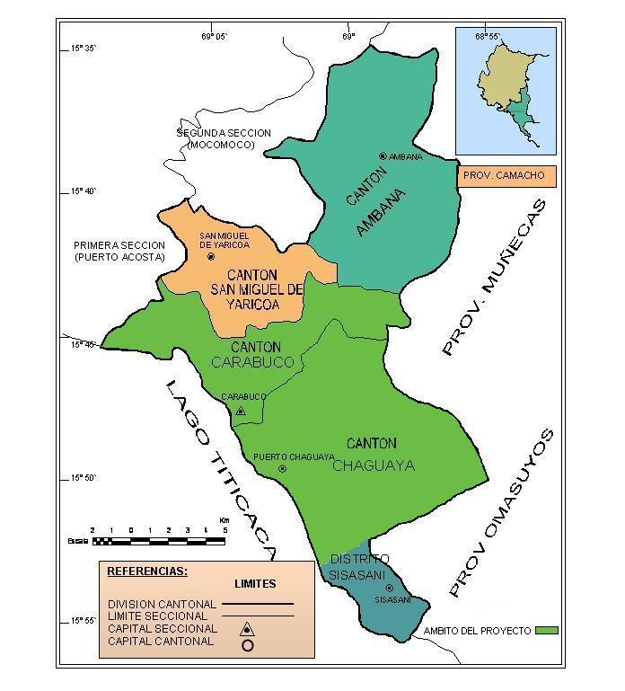

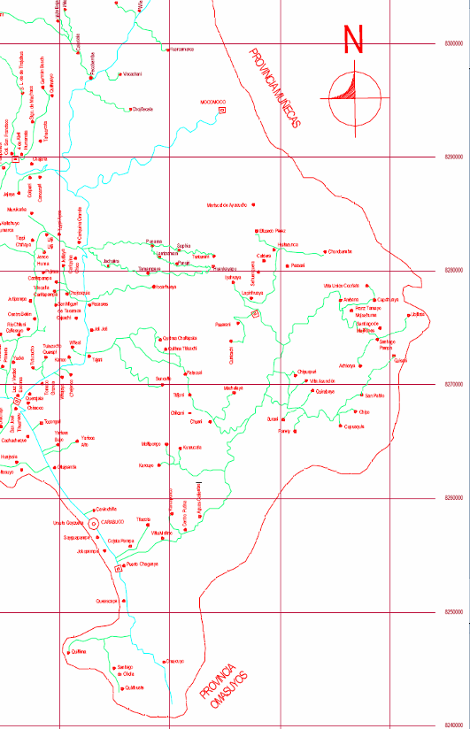

Description of the Planning Phase

In order to make easier the planning of the project, we will promote the participation of the communities involved and of the municipal government of Puerto Carabuco. In order to do this, the following actions are proposed:
- Interviews with municipal authorities and agricultural labor unions.
- Gather and analyze secondary information on the Carabuco Municipality
- Visits to communities that are part of the project for a quick diagnosis
- Explanation and Understanding of the project by the Municipal Government of Puerto Carabuco
- Carrying out a consciousness-raising workshop on present and future climatic variability and presenting the project to participating communities.
- Signing a letter of intent with the Municipal Government of Carabuco

After carrying out the consciousness-raising workshop and the project’s presentation, staff from Cuna Association, in coordination with technical staff from the Municipality, will carry out the workshop to assess the initial VRA of the 5 communities of the project, with the participation of the inhabitants, tarwi producers and/or local leaders. The questions to be used are as follows:

APF Step | VRA Indicator | Questions
Evaluation of present vulnerability | 1. Vulnerability of living means/wellbeing to present climate change and/or climate variability | How do droughts, hailstorms and other climate phenomena affect your tarwi production?
Evaluation of present vulnerability | 2. Efficacy of the measures for the adaptation to present risks of climate change/climate variability | How would your community face the negative effects of climate variability on their agricultural cultivations?
Evaluation of future climate risks | 3. Vulnerability of living means/wellbeing to climate change risks that are developing | If the adverse climate phenomena, such as droughts, hailstorms and other, were to become more frequent, what would their effect be on your living means?
Evaluation of future climate risks | 4. Ability of the community to face the climate change risks that are appearing. | How would your community respond if the adverse climate phenomena were to augment?
Budget for the Planning Phase
 | Item | Total Cost | CBA Amount | Proponent Amount
1 | Project coordinator (1.5 months x 700$US/month, full time) | 1050.00 | 1050.00
2 | Travel expenses in rural areas | 180.00 |  | 180.00
3 | Transport of community members to workshops and meetings | 150.00 | 150.00
4 | Fuel | 300.00 |  | 600.00
5 | Desk materials | 200.00 | 100.00 | 100.00
6 | Printed materials | 150.00 | 105.00 | 45.00
7 | Copies | 25.00 | 25.00
8 | Workshop and meetings with communities | 100.00 | 100.00
9 | Phone/e-mail | 50.00 |  | 50.00
10 | Computer/Printer/Desk | 100.00 |  | 100.00
11 | Cars maintenance | 300.00 |  | 300.00
12 | Workshops and meetings with communities | 150.00 | 150.00
13 | Overheads | 170.00
14 | Transport ticket for project’s staff | 100.00 | 100.00
Total |  | 3025.00 | 1780.00 | 1375.00

Bank Information

Bank’s Name: BISA Bank
Bank’s Address: Av. 16 de Julio Nº 1628 La Paz Bolivia
Account number and currency: CTA. CTE. Nº 128301-001-1, National Currency Bolivianos
Account number and currency: CTA. CTE. Nº 128301-201-4 Foreign Currency, US dollars.
Account beneficiary (name and address): Asociación Cuna, C. Estados Unidos Nº 1487 esq. Puerto Principe zona Miraflores La Paz Bolivia
Legal representative: Juan Ramírez Quijada NATIONAL DIRECTOR OF CUNA ASSOCIATION

