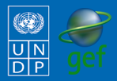
Community-Based Adaptation
FAST FACTS

Grantee: Farmers Foundation of Kazakhstan
Type of organization: NGO
Number of participants: 3,100
Location: Lepsy Village, Sarkand District, Almaty Oblast, Kazakhstan
CBA Contribution: $48,030 USD
Project Partners: ARAI Youth Center NGO; Akim and Lepsy Forestry Management Departments

Co-financing: $55,947 USD
Project Dates: February 2009 - February 2011
KAZAKHSTAN
Adapting to increased aridity in the livestock-raising community of Lepsy

BACKGROUND
The Community-Based Adaptation Programme (CBA) is a five-year United Nations Development Programme (UNDP) global initiative funded by the Global Environmental Facility (GEF). Partners include the GEF Small Grants Programme (SGP), the Government of Japan, AusAID, UN Volunteers, and local NGOs. The CBA’s goal is to strengthen the resiliency of communities to adverse climate change impacts.

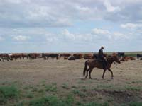
One CBA project, “Adapting to increased aridity in the livestock-raising community of Lepsy”, focuses on the pastoral community of Lepsy, in the northern desert of Kazakhstan. The climate in Lepsy is extremely dry, with long, cold winters and hot summers. Winter snow is the only agriculturally useful precipitation: melting snow seeps into the soil and contributes to soil moisture and groundwater, but summer precipitation evaporates too quickly to be absorbed by plants. This fragile ecosystem, consisting of sandy hills covered with wheat grass and cypress vegetation, is threatened by increasing aridity. The environment also suffers from poor pasture management. Disruptions to traditional seasonal grazing and pasture rotation practices have resulted in overgrazing. The community’s livelihoods depends largely on products generated by livestock. In order to raise high quality cattle local residents must have access to fertile pasturelands. Increased aridity brought on by climate change puts both the ecosystem and inhabitants’ livelihoods at risk by reducing the amount of forage available for grazing. Having observed the negative impact of climate change upon livestock productivity, the community has has decided to implement adaptation measures to ensure that climate change doesn’t further threaten their livelihoods.
Cattle grazing near Lepsy Village. In many parts of Kazakhstan overgrazing is already a problem. Climate change impacts will add additional pressure on fragile rangeland soils and ecosystems.

CLIMATE CHANGE RISKS
Long-term climate change projections for Kazakhstan forecast rising temperatures and declining average rainfall, leading to increased aridity in an already very dry country. Drought is the main climate risk in the project site: the dry period has already expanded in recent years as the precipitation levels have dropped and temperatures have increased, especially in winter. Moreover, hot, dry winds from the south are increasing. As a result of these changes, there is less soil moisture available for fodder growth in springtime. Sparse vegetation lowers livestock grazing capacity while also contributing to pasture degradation. The impacts of climate change severely threaten the livelihoods of this already economically-depressed region.

Contact information: CBA Project Management Unit at cba@undp.org
304 East 45th St., 9th Floor New York, NY 10019 Tel: (212) 906-5006

PROJECT DESCRIPTION AND ADAPTATION
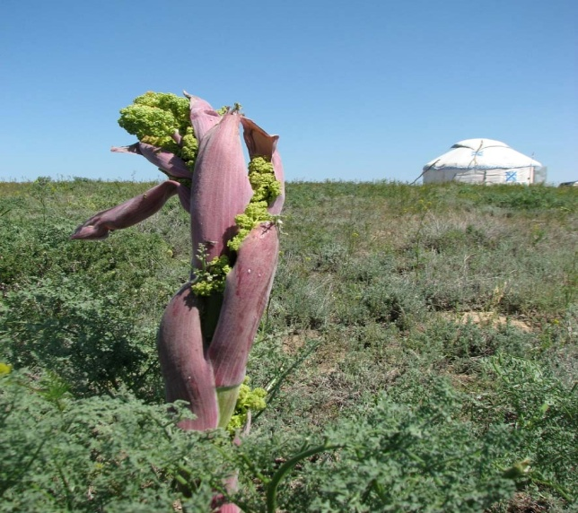
SOLUTIONS

This CBA project aims to reduce the community’s vulnerability to climate change and conserve the sand pasture ecosystem. Prepared through a participatory process carried out by the local NGO, Farmers Foundation of Kazakhstan, the project is working to protect the viability of residents’ pastoral livelihoods.

The community is benefitting from the implementation of pasture management practices that maximize scarce water resources. Sustainable strategies to reduce the grazing load and enable cattle distribution include:

- Transferring some cattle to unused remote rangelands
A remote rangeland near Lepsy village that will be used as part of new grazing management strategies.
- Arranging seasonal pasture rotations
- Optimizing water supplies through the rehabilitation of traditional wells
- Ensuring optimal loads on new pastures through pastoral management agreements between the cattle owners

The project also contains an important capacity-building component that trains community members in water and pastoral resource management. Additionally, practices that best reduce climate change impacts on sandy rangelands will be disseminated for use in similar ecosystems in Kazakhstan, which total more than 31 million hectares.

FOCUS ON…
Livelihood benefits
As a pastoral community, Lepsy survives mainly on products generated from livestock, such as milk, meat, and wool, because the harsh climate makes farming agricultural crops impossible. However, the productivity and quality of this livelihood is seriously threatened by both climate change (increasing aridity) and human pressures on the land (overgrazing). For instance, under-fed animals sell at low prices and produce little milk. Therefore, strengthening the adaptive capacity of community members not only contributes to protecting an increasingly fragile ecosystem, but also to ensuring sources of income.

Voluntary community participation


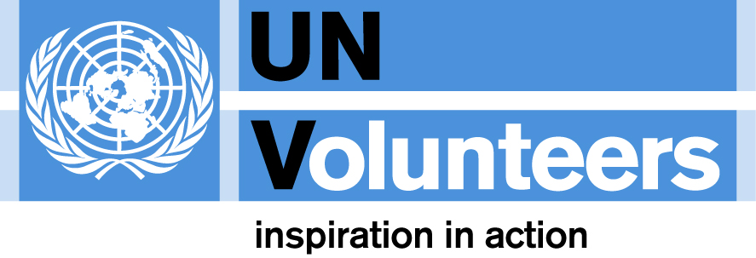

Facilitated by the Farmers Foundation of Kazakhstan, this community-driven project has been formulated as a result of discussions with local cattle owners and agricultural specialists living on site. The project works with livestock owners to transport 2,000 sheep and goats and 300 cattle to remote rangelands found 25-30 km away from the village. From design to implementation, community members have willingly dedicated their time, labour, materials, and knowledge to sustain and improve their pastoral livelihoods.
For more information about CBA or CBA projects visit: www.undp-adaptation.org/project/cba
Further information, lessons learned, and experiences gathered from climate change adaptation activities globally can be found at the Adaptation Learning Mechanism: www.adaptationlearning.net

