Entering CBA M&E Information into the SGP Database

WHY?
Monitoring and evaluation information, including VRA scores and qualitative information and IAS indicators, should be entered into the SGP database for every CBA project. This allows the CBA to track to progress at the project and portfolio level. It is an essential part of the M&E crucial to project success.

HOW?
How to add project indicator data
If the CBA project has not been entered into the SGP database, you will need to go to the SGP Projects tab on the main SGP database webpage (http://sgp.undp.org/intranet/admin.cfm) and select the “Add new project” feature on the left side of the page and add the project information. Once project information is entered, follow the instructions below.
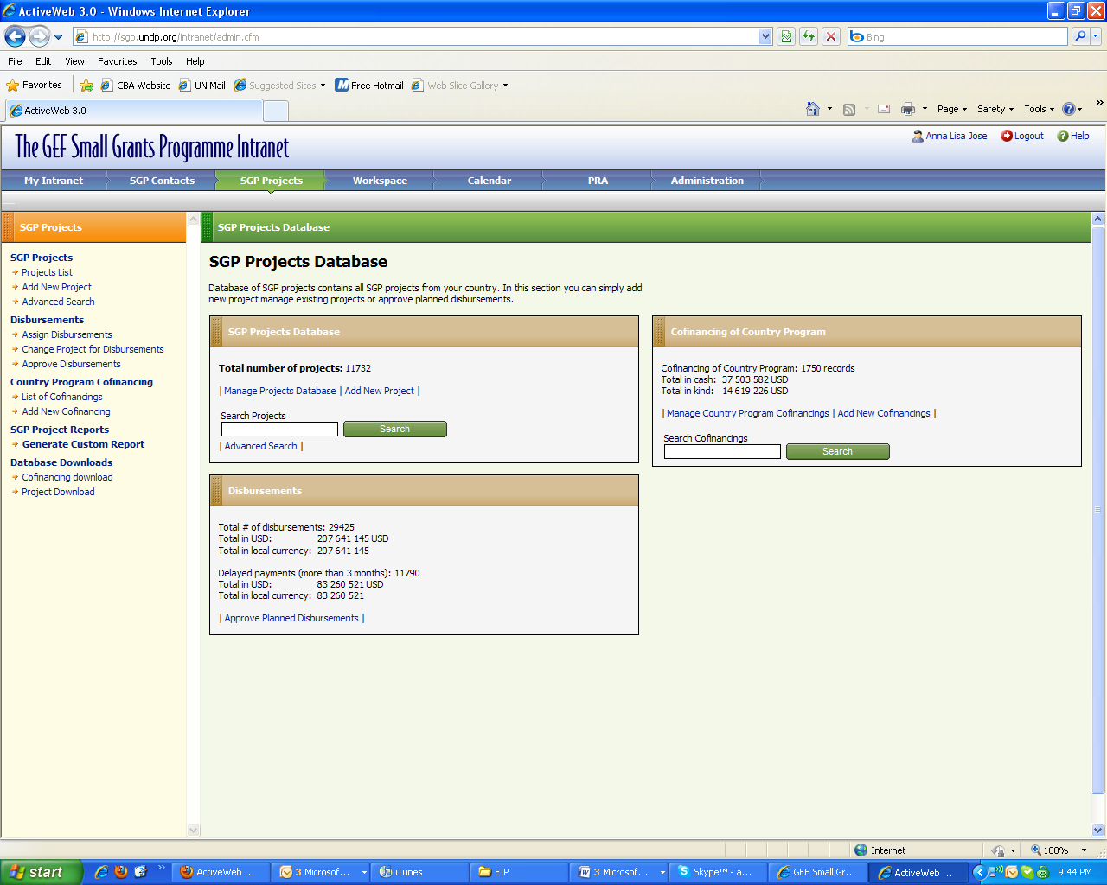
1
2

For CBA projects already entered into the SGP database click on the paper icon on the top right left corner.
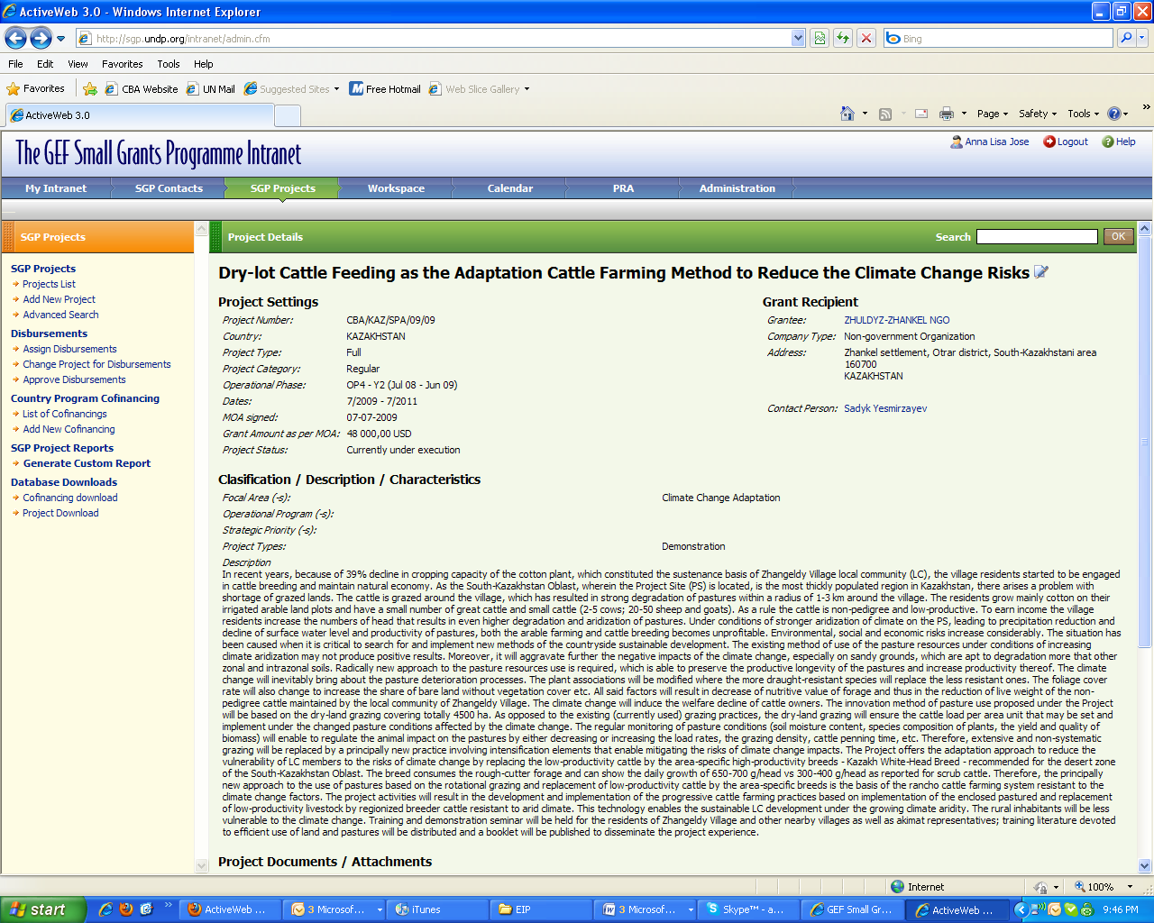

Click on the “Indicators” tab at the top of the screen.
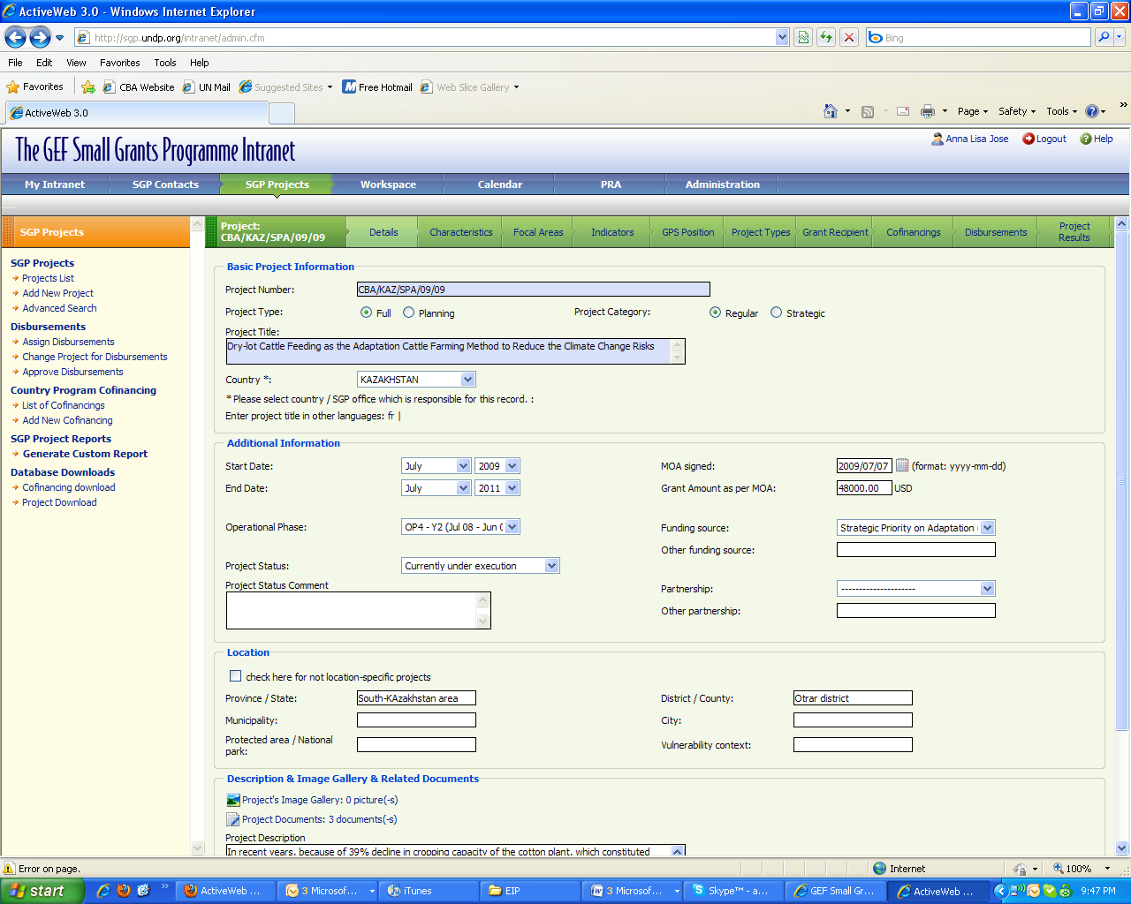
Then select “Add new project indicator” under Climate Change Adaptation.
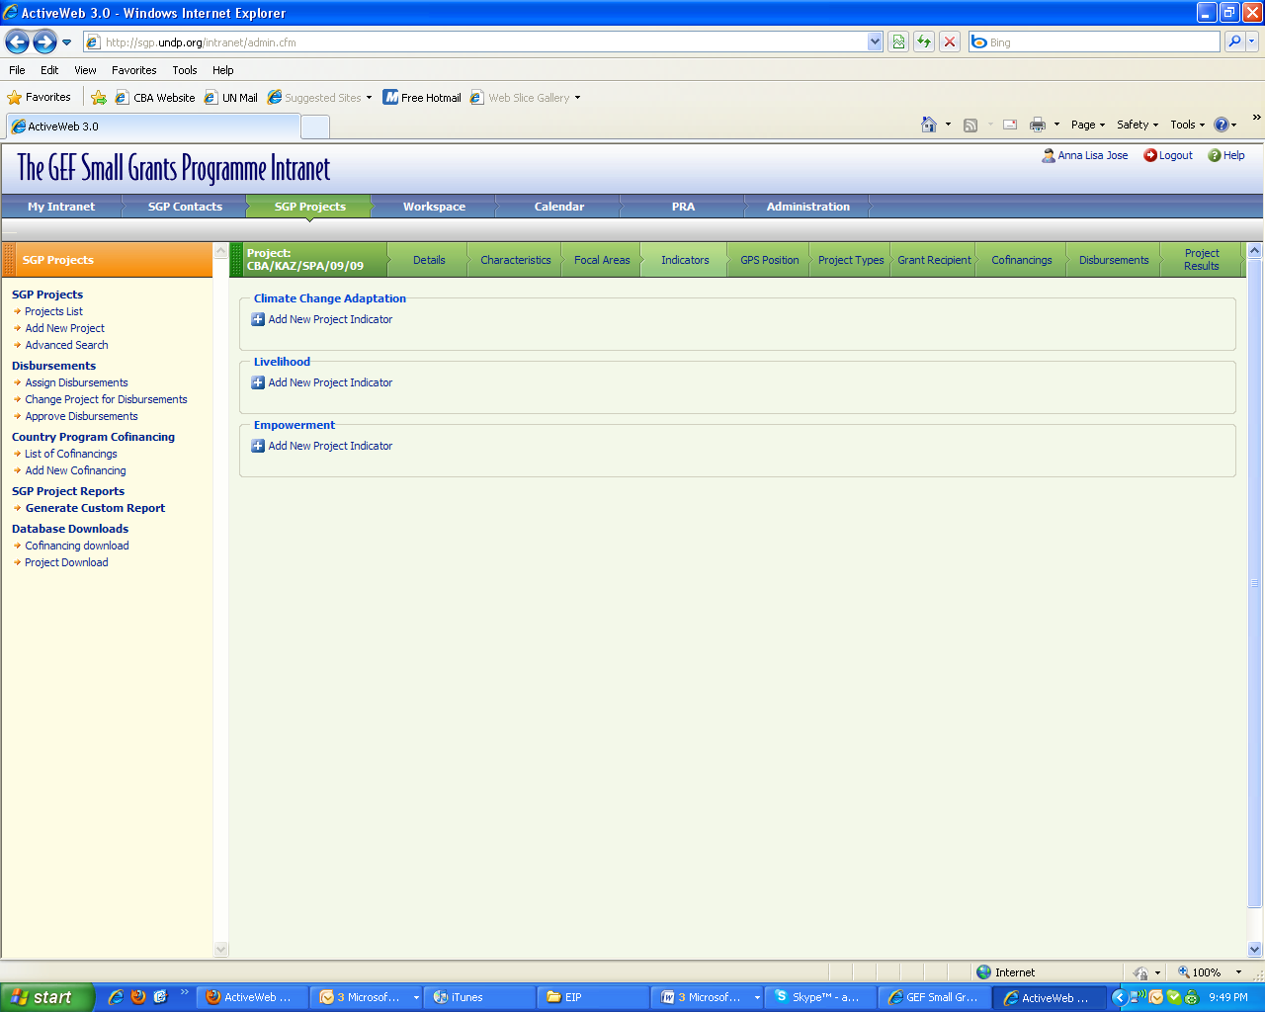
Adding VRA information
You can now enter the information for each VRA indicator.
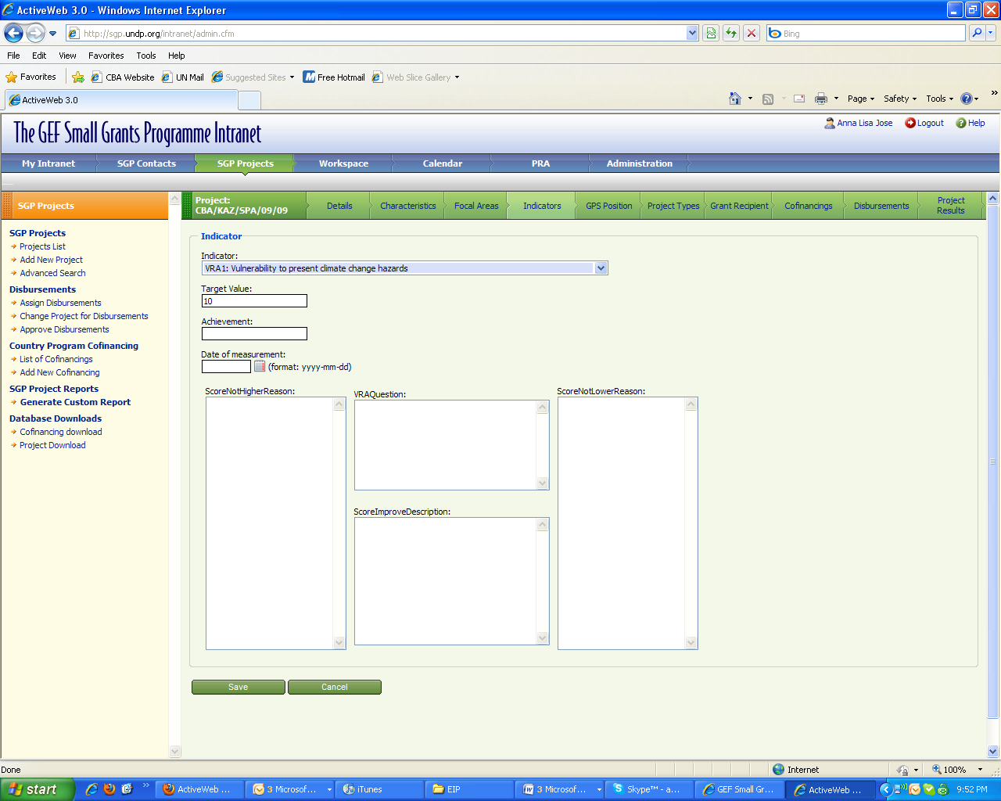

For VRA-there are four indicators, as follows, rated on a scale from 1 (very bad) to 5 (very good)
1. Vulnerability of livelihood/welfare to existing climate change and/or climate variability.
2. Vulnerability of livelihood/welfare to developing climate change risks.
3. Magnitude of barriers (institutional, policy, technological, financial, etc) barriers to adaptation.
4. Ability and willingness of the community to continue to manage climate change risks

The first version of the VRA was based on seven indicators scored on a 1-10 scale. THIS HAS CHANGED. The SGP database is still set up to enter seven VRA indicators. Since the VRA now has four questions, please enter the scores for indicators 1, 3, 5, and 6. You do not need to fill in scores or information for VRA indicators 2, 4, 7. For scores taken on the 1-5 scale, simply multiply the scores by 2 to convert to a 1 to 10 score. We will try to revise the SGP database to reflect the revised VRA scoring system.

VRA sessions should yield both quantitative (scores) and qualitative information (reasons for the scores) on community perceptions of vulnerability. BOTH QUANTITATIVE AND QUALITATIVE VRA INFORMATION MUST BE ENTERED INTO THE SGP DATABASE. When each individual VRA indicator is added, you will see an H-form (see example below). This is meant to resemble the H-form used during VRA sessions. To complete the form enter the target value (10), score measured (on a scale from 1 to 10), and date of the VRA session. In the center of screen, enter the VRA question used (this will be the VRA questions for each indicator indentified in the project concept). To the left of the question, enter reasons for negative responses (low score) and challenges. To the right enter reasons for positive responses (high score) and mitigating factors. Below the VRA question, enter community suggestions for how to improve the score.
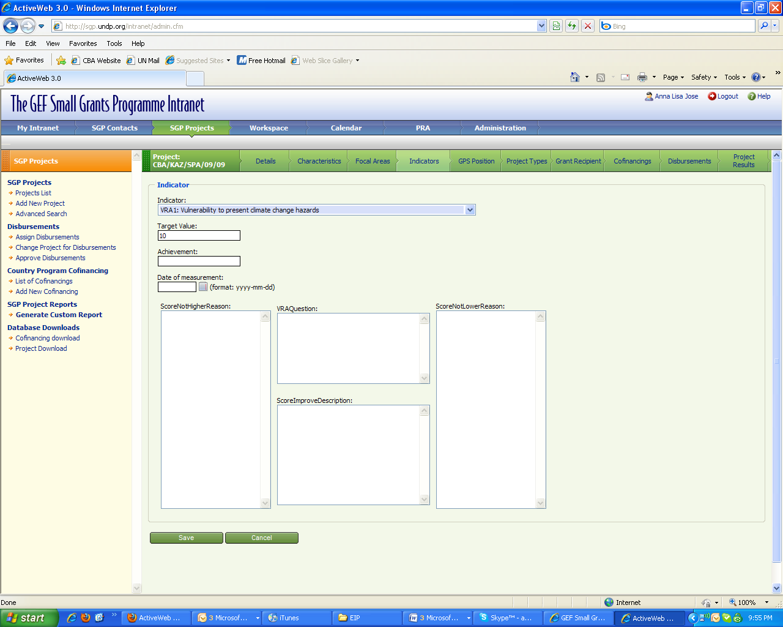
Reasons for positive responses (high score)
Reasons for negative responses (low score)
VRA questions used
Community suggestions for how to improve the score

If you’re unfamiliar with the VRA indicator system, please refer to the VRA Working Paper, especially pages 5-13. It is available on the CBA website at:
http://www.undp-adaptation.org/projects/websites/index.php?option=com_content&task=view&id=206
French and Spanish versions are also available.

Here’s an example of what a completed H-form should look like.

Adding IAS information
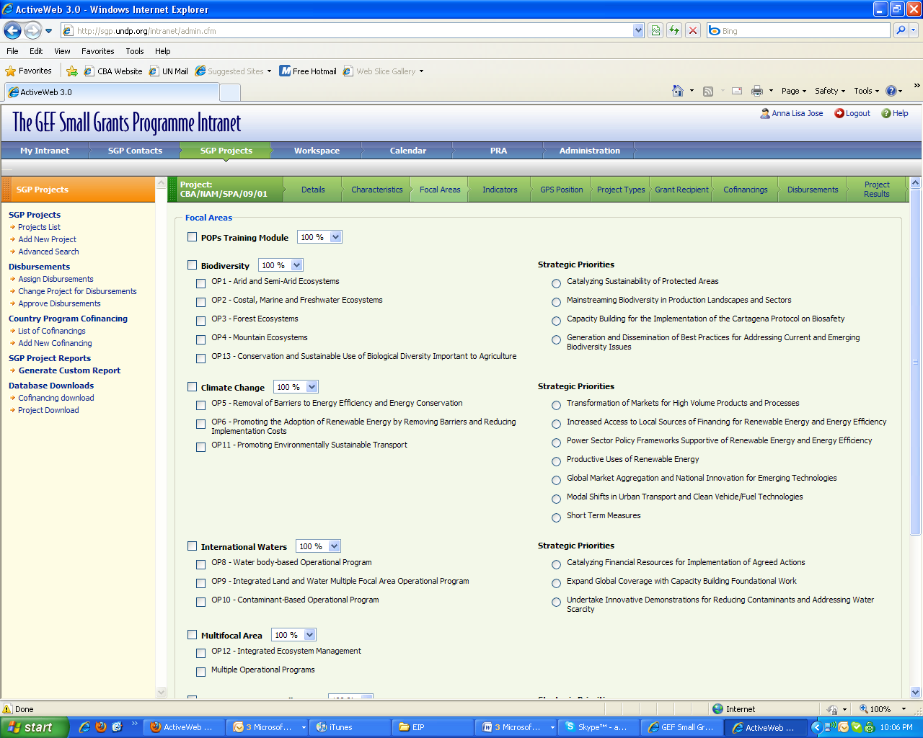
IAS indicators also need to be entered on the “Indicators” webpage for each project. The IAS indicators will correspond to the focal area of the project (land degradation or biodiversity). One or more biodiversity or land degradation indicators should be chose and reported on for each CBA project. To get the appropriate IAS indicators on the “Indicators” menu and chose the appropriate Focal Area under the “Focal Areas” tab.
2. Select appropriate focal area

- Go to Focal Areas tab

Then select “Add New Project Indicator” and add the appropriate IAS indicators.
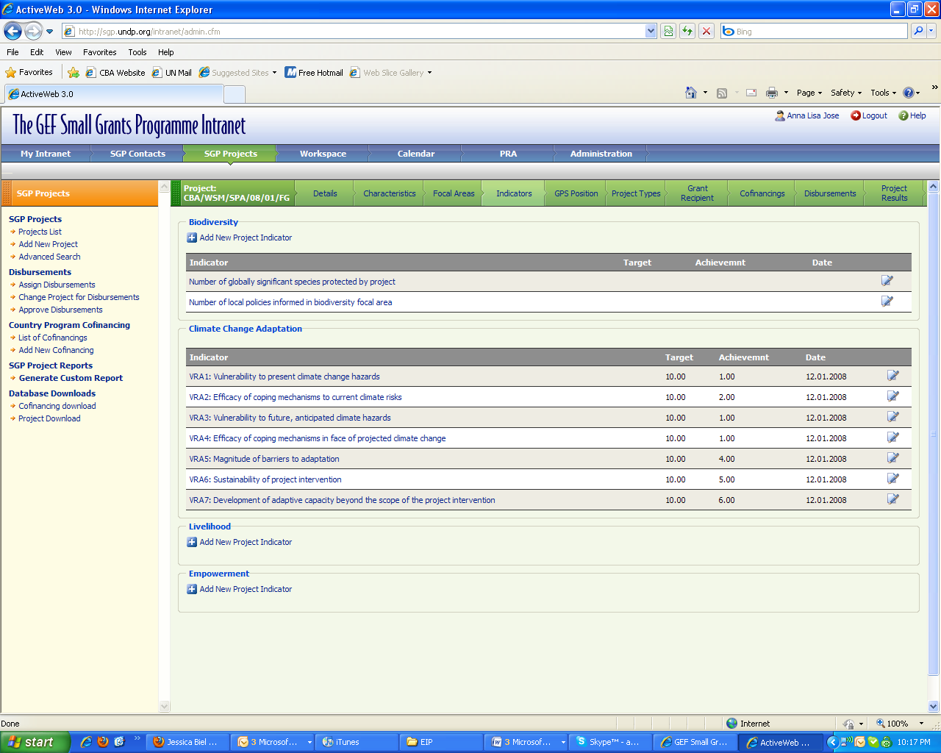
For each indicator, there will be a screen like this where the target value and date of measurement, as well as any notes, should be entered.
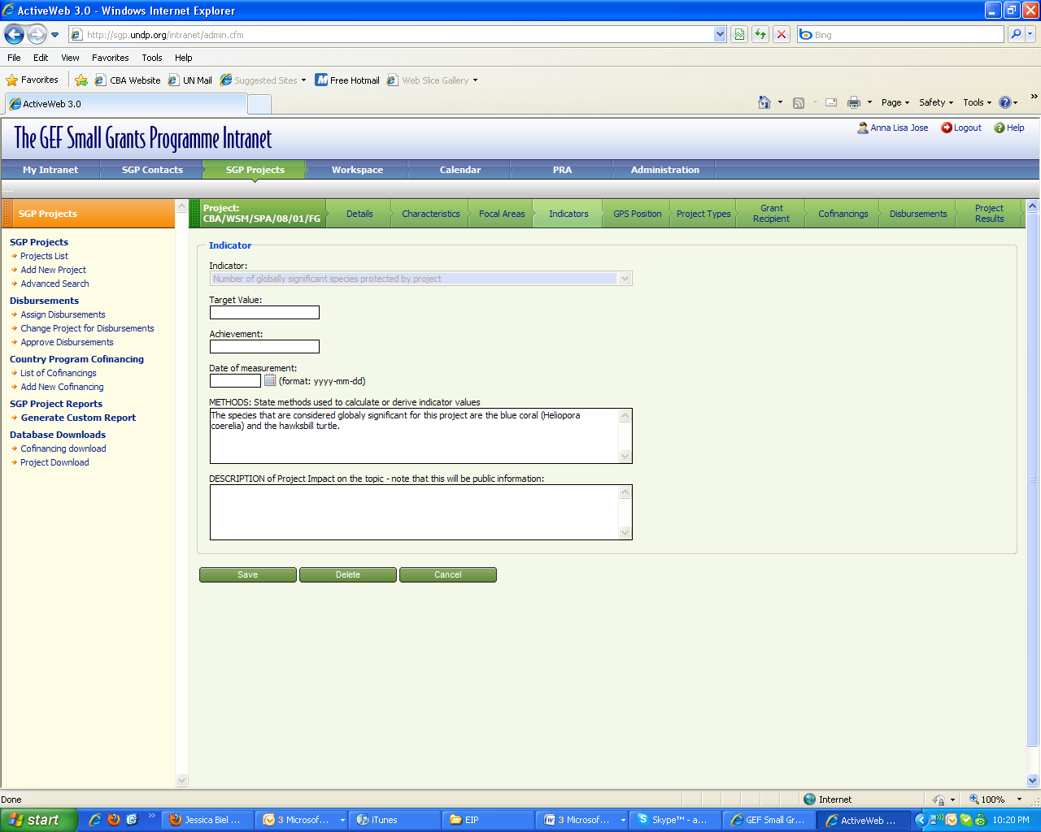
WHEN?
VRA information should be entered into the SGP database after each VRA session. Normally, VRA sessions are held during project preparation, at the mid-point, and at a project’s end. NCs may choose to do more VRA sessions. Provided that there are clear notes from the VRA sessions, it should take about 30 minutes to 1 hour to enter information after each VRA session. IAS indicator data (including targets) should be entered after projects have been approved and updated when new data comes in during implementation.

WHO?
Anybody who has access to the SGP database can enter this information. Thus, NCs, Programme Assistants, or UNVs can do this. Each country programme can decide the most efficient way to enter this data. UNVs can also assist with taking notes and capturing information during VRA sessions in the field and subsequently help input this information into the SGP database.

THE BOTTOM LINE
All projects that have completed at least an initial VRA exercise (this means all projects that are either under implementation or have a completed proposal) need to enter both quantitative and qualitative information for each VRA session and IAS indicators. Qualitative VRA information is especially important as it can help track project progress (or problems over time) and helps capture information for lessons learned and knowledge products. It also helps provide necessary the context to explain the VRA scores.

A spot check of the SGP database reveals that while some projects have entered the quantitative information (the scores), no projects have entered the qualitative information (the reasons for the scores). All country offices should enter this information by Friday, October 23. The PMU will then check the SGP database to ensure compliance.

QUESTIONS?
As always, the PMU is here to assist. If you have problems entering information into the database, please let Anna Lisa or myself know.

