GEF SPA CBA COUNTRY PROGRAMME REPORT – (KAZAKHSTAN)
February 2008 – December 2012 Country Outcome Review

portfolio Overview

Being the ninth largest country in the world in terms of area, Kazakhstan has a vast territory that in turn determines the existence of basically all the natural and landscape zones, from forests to deserts.

Kazakhstan's location in the middle of Eurasia determines its extreme continental climate. Based on the projections provided by international experts in the field of climate change, the major climate risk for Kazakhstan is the elevation of average annual temperature with the current level of precipitation preserved thus even more aggravating the ongoing climate aridization processes. Said factor is a serious threat to both the natural ecosystems and the community development as a whole. The climate change may increase and result in the negative consequences such as frequent draughts, intensified dry hot winds, the shift of the natural and climatic zones, changes in the hydrographic regime of water sources etc. Considering the fact that the major part of the country's territory is under pastures and plough-lands that are roughly degraded as well as the fact that Kazakhstan is highly dependent on external water sources (all the rivers running across Kazakhstan head outside of the country) whose water inflow volumes reduce from year to year, the aggravation of climate aridity endangers the sustainable development of ecosystems and communities that directly depend upon their conditions. The increased erosion of plough-lands and degradation of rangelands given the intensified draughts, dry hot winds and reduction of precipitation levels will result in the decline in crop yields and quality of cereals as well as the productivity of livestock. All said factors will have an adverse impact on the social-economic position of people, especially those living in the rural areas.

The CBA Program's project portfolio was built on a number of major aspects. First, taking into account that the degradation processes have been quite seriously manifested across Kazakhstan, the increased climate aridity will even more aggravate this problem. Second, agriculture is the major source of income for many rural communities; practically half of the country's population are the rural residents involved in agriculture and are thus most vulnerable to the ongoing climate changes. That is why agriculture was selected as a priority sector, and the issues of degradation alleviation are viewed as a priority environmental problem.

Taking into account quite a small amount of grant funds allocated for the demonstrational component (US$400,000), it was necessary to form the project portfolio in a way that the most vulnerable sectors could be covered (specifically, grain production and grazing cattle farming) whereby the diversity of approaches and efficient methods could be demonstrated and applied contributing to mitigation of the main risks, specifically: reduction of water resources and efficient land resources management covering different areas of the country. And certainly, the community willingness to apply the new adaptation practices also needed to be taken into account.

It needs to be taken into account that one of the most conflicting problems connected with the global climate change in Central Asia will be the problem of water use and distribution of water. In this connection, the problem of efficient water resources management was also taken into account in the CBA project portfolio formation.

In 2007-2008, at the initial stage of CBA Program, a series of consultations, meetings and workshops have been held in the field of adaptation and formulation of project proposals directly in the regions, both on the basis of SGP GEF partner organizations and the communities themselves.

As a result of preliminary work accomplished a primary project portfolio of project ideas has been formed. The next stage was to translate the ideas into projects. The challenges included, first of all, the lack of experience of NGO's and communities in drafting the adaptation projects. That topic has never been considered before and at the beginning of the Program the communities had no any capacity on the issue. Therefore the additional external expertise was required. Another barrier was the necessity of obtaining the data on the climate change trends as of the recent decades as well as making the forecast for the nearest future in order to understand the directions to be followed and the activities to be implemented. Taking into account the above-mentioned challenges, at the beginning it was decided to allocate a number of planned grants whose main purpose was to assist the local communities and NGO's in developing the full-fledged projects focused on the implementation of efficient adaptation climate-resistant practices.

A total of 10 planning grants were allocated for the amount of US$20,000. The table below shows the comparison of resources allocated for project writing and directly for the implementation of the demonstrational component. A small percentage of grant funds allocated for project writing has made a considerable contribution to the formulation of an adequate project portfolio in the shortest possible time.
As a result of planned grants allocated 9 demonstrational projects have been developed and one additional project has been written independently by an NGO apart from the planned grant.

Thematically, the projects have covered the main sectors such as grain production and animal husbandry. The tables provided below clearly demonstrate the projects distribution by sector (by a number of projects (chart one) and by amount of funds (chart two)).

The main geographical areas have also been covered; the North and Central Kazakhstan for grain production and the South and Southeast Kazakhstan for grazing cattle breeding.
(The grain production projects are given in red and the cattle breeding ones are presented in green).
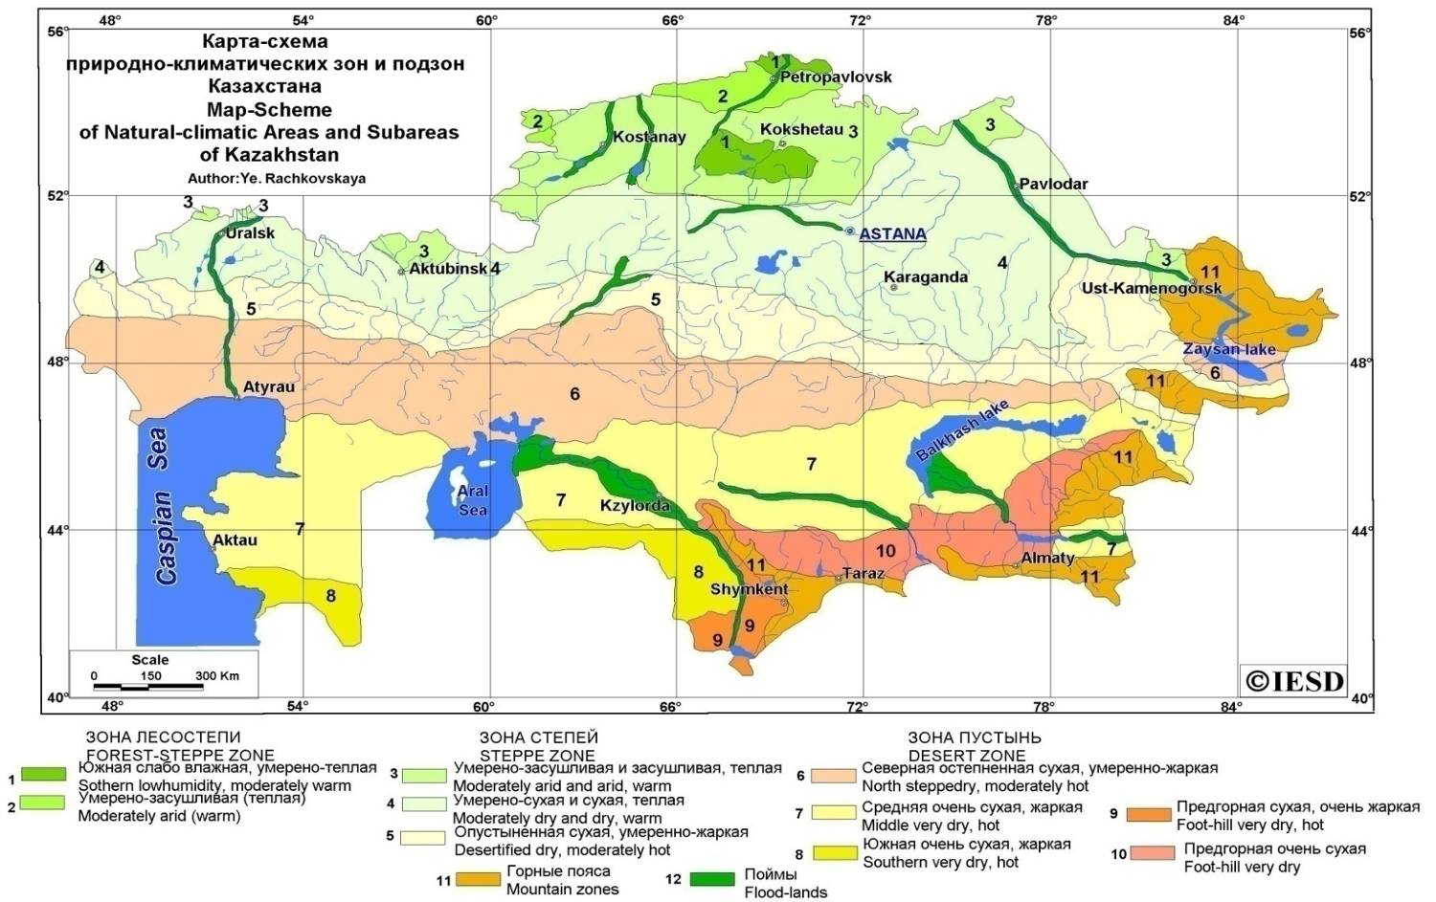

6 of total 10 projects of the CBA project portfolio have been proposed by NGO's and 4 projects have been formulated by the local communities who have later established and registered their NGO's.

The total cost of CBA portfolio in Kazakhstan is US$488,890 including 10 planning grants (US$20,000) and 10 demonstrational projects (US$408,890) from total of the GEF funds. The additional co-financing was provided by the Swiss Government to enhance the project activities under 6 ongoing projects for the total amount of US$60,000.

Owing to CBA pilot initiatives implemented, 10 rural communities in the most vulnerable areas in terms of climate change impact have gained the direct benefits, over 40 communities have gained indirect benefits (in the form of information concerning the new methods and approaches; training and workshops, study tours etc.). For that purpose the focus was mainly on women and the most socially and economically vulnerable groups (lonely elderly people, mothers with many children etc.). Under CBA projects said people have been provided aid for the total amount of about $10,000. The positive impact on the conditions of ecosystems in the priority geographic areas within the focal sector identified (land degradation) has been made with more than more than 20,000 ha of area coverage. Over 5000 people have been involved in the projects including 30% women and young people.

Despite the fact that, contrary to the other countries, the UN Volunteer Program has not been represented in CBO activities (due to very limited activities and the staff of the organization), many projects envisaged the volunteer component that is essential for the successful project implementation. To that end, the emphasis was not only on the local adult people but also on the youth essentially who have also been actively involved in the project initiatives. The volunteer groups have been formed within the projects represented by high school students, young people, women who not only have participated in the project training and workshops dedicated to the project issues but also in the advocacy and implementation of the pilot initiatives as well as the monitoring and evaluation exercises through VRA workshops where they shared their opinions and views. On a volunteer basis, the members of local community have performed a large amount of preparatory work to identify the project ideas, discuss the project concepts and specific activities, to assess the necessary scope of work and compile the budget. The main project initiators have organized and established the initiative groups that were actively involved on a volunteer basis throughout the entire project cycle.

In particular, within the project implemented by Akbota PF «Adaptation of farmers’ agricultural practices in response to intensified climate aridization in Akmola Oblast (CBA/KAZ/SPA/09/01)», from its starting date through completion, the volunteers represented by the young and adult people (mainly women), seeing the benefit of the proposed water-saving technologies, have on a free-of-charge basis actively assisted the project in organizing the irrigated fields of LC members using the drip irrigation system; have been actively involved in the installation supervision and reconstruction activities; have been present at the measurement works and irrigation activities; taken part in the public control of winter crops planting and observation of the entire cycle of planting and harvesting irrigation activities; have taken the readings of water consumption for both traditional and project proposed irrigation methods. The involvement of women and young people was the most salient aspect in the project progress. The women were actively involved in the project activities since the drip irrigation technology enabled to considerably reduce the intensity of women's labor and was the factor to stabilize family relations and improve the income of households.
As a whole, the projects contributed to the volunteer movement development on the spot.

Thematic Focus
According to the forecasts provided by the international experts, based on the median greenhouse gas emissions scenario for Kazakhstan, by 2030 the average annual temperature will elevate on average by +1,4 °С; by 2050 – by +2,7 °С; and by 2085 – by +4,6 °С. According to the climate experts' observations, even now Kazakhstan has outstepped the point of +1.4 С. This indicates the higher rates of climate change and thus the elevation of the associated risks.
The factor of temperature elevation is the determining one. Given the existing average annual level of precipitation and its re-distribution where most of precipitation will occur in winter, an adverse impact will be on agriculture and result in the northward shift of moisturizing zones by 250-300 km on average. As a result, the northern areas of Kazakhstan (grain production regions) will find themselves in the arid zone, and the rest of the territory will also belong to the arid zone.
The focus of CBA activities in Kazakhstan was the mitigation of the main climate-related risks primarily connected with increased aridization on the local level through the rural communities' capacity building and development as well as implementation of efficient new adaptation natural resources management methods in view of the climate change trends. In the context of said priority, the project portfolio has been developed in view of the main indicators –achievement of the global environmental benefits (GEB) while reducing the vulnerability of ecosystems and local communities to the ongoing climate changes. Taking into account the problems of land resources degradation (over 70% of lands are exposed to degradation and desertification processes) existing in Kazakhstan and based on the experts' forecasts concerning intensification of said processes in view of the ongoing climate changes, the land degradation combat was identified as the main focal area for CBA activities in Kazakhstan. What was the basis for selecting said priority?

It follows from the data of the survey performed while preparing the first and the second national communications under UNFCCC that the most vulnerable sectors requiring the urgent adaptation measures are the agriculture, water and forestry sectors as well as emergency sector. While identifying the priority areas of CBA activities, a number of consultations were held with various groups of experts, NGO's, governmental agencies etc. As a result of such numerous discussions, the decision was made that CBA activities need to be focused on the agricultural sector, specifically, on cattle farming and grain production.

Agriculture is the sector where the relation between the opportunity of GEB in the land degradation focal area and ensuring sustainability of ecosystems and local communities to the climate changes is the most apparent. In addition, agriculture is tightly related to national priorities and meets the needs of rural inhabitants that are most vulnerable to the climate change consequences due to direct dependence of their livelihoods upon the weather and climate changes.

In the main agricultural areas of Kazakhstan, the climate determines draughts, dry hot winds as well as late spring and early autumn frosts along with the other weather conditions unfavorable for agriculture. The elevation of average annual temperature given the reduction of air precipitation in warm season and increased precipitation in cold season – all said factors result in the depletion of spring and summer reserves of soil moisture that essentially determines the crop yields.

Grain production is the main element of food safety in Kazakhstan. Being dependent on any fluctuations of temperature and precipitation, grain production is pretty vulnerable in terms of sustainable development. Precipitation is the factor on which the yields of agricultural crops directly depend. In some years, the dramatic changes in temperature, frequent draughts, reduction of precipitation in spring and summer result in 50-70% loss of crop yields.

The North Kazakhstan that contains 83% of summer wheat plantations belongs to the high-risk land-farming zone. Up to 60-70% risks are connected with the weather and climate dynamics. Within the latest 30 years, the climate change in this area has made a considerable contribution to the decline in the crop yields of summer wheat for the period between 1984 and 2003 from 0,76 t/ha to 0,63 t/ha. Under the influence of draughts, the annual yields of summer wheat in this area may change 4-6 times. Grain production in the North Kazakhstan area is the living base of most of the rural residents whose well being is mainly connected with wheat crop yields. The intensified climate aridization puts at risk the sustainable development of both individual communities living in the area and the country in general.

Cattle farming is a historically developed industry that has traditionally existed for centuries. To date, sheep breeding plays a key role in cattle farming. In 1987, the stock of small cattle (sheep and goats) in Kazakhstan has reached the maximal number and made 36.7 million heads and since 1998 this number has dropped to 9.5 million heads in the period of economic crisis. As from 2001, due to the overall economic growth of Kazakhstan, sheep breeding has got a new shot in the arm and the annual growth of sheep stock was about 1 million heads. Fo the time being, it makes more than 18 million heads. In Kazakhstan, about 87% of total agricultural cattle stock are owned by the private cattle farms, and the remaining 13% are owned by agricultural enterprises. Sheep breeding is most developed in the south, southeast and east of Kazakhstan. 58% of total stock of sheep and goats are maintained in the 4 southern regions, South Kazakhstan (21%), Jambyl (14%), Almaty (18%) and Kyzylorda (5%) oblasts.

The natural and climatic conditions of the areas where sheep breeding plays a key role enable cattle grazing all the year round. However, pastoral ecosystems are also vulnerable to the extreme weather and climate changes. Sudden thawing and frost in winter and early spring frequently result in the mass loss of cattle. The draughts in summer lead to the lack of forage, the necessary guarantor of the sustainable sheep breeding development. The climate changes that have occurred within the recent 40 years have shown a certain influence on the maintenance conditions (grazing) of sheep over the course of the year. In the south of Kazakhstan a clear trend is seen whereby in cold seasons the grazing period is reduced and cattle are maintained in housing conditions.

Concerning the influence of climate change on cattle farming development, we may note that as in the case of grain production, this sector is also quite vulnerable. The natural and climate conditions determine the conditions of pastoral vegetation and thus directly influence the conditions of cattle. Considering the projected and currently observed climate changes towards aridization, the natural pastoral vegetation is depleted resulting in the loss of rangeland productivity and reduction of the limited water resources. The load on the near-village pastures is growing thus leading to overgrazing and intensified degradation. At the same time, the undergrazed remote pastoral lands fall out of grazing rotation and are overgrown with weeds.

Geographic focus.

The geographic priority in CBA activities was directly connected with and followed from the selected thematic priorities and key indicators: GEB achievement in the field of land degradation in parallel with the improved sustainability of ecosystems and vulnerability reduction of people engaged in key agricultural sectors under the climate change conditions. Both national and local development priorities were also taken into account.

Consultations with the national experts have resulted in the selection of the two priority sites as described below:
- Boundary area between steppe and semi-desert, at the junction of three administrative provinces (Kostanai, Akmola and Karaganda) – the northern site of the Program activities;
- Boundary area between semi-desert and desert in the north of Almaty, Jambyl and South-Kazakhstan provinces as well as the northeastern part of Kyzylorda province - the southern site of the Program activities.

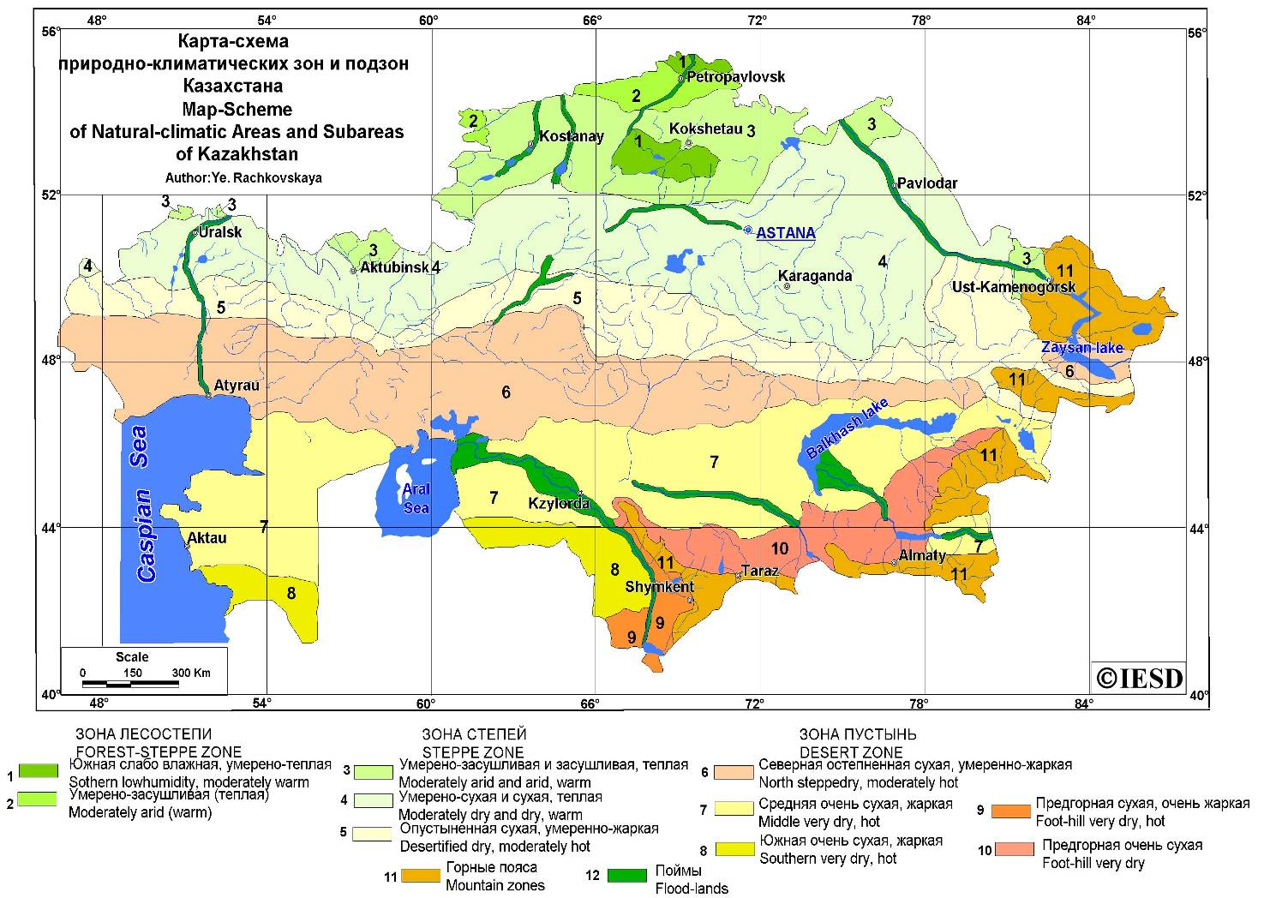

Viewing the sites as mentioned above in terms of the degradation problems it needs to be noted that the areas in question show high degree of said processes. The northern areas selected as a priority belong to the grain production sector. Here the main problem lies in the application of extensive agricultural technologies. In the southern areas being part of the stock farming region and the irrigated land-farming zone, the main reason underlying the problem is the use of inefficient soil treatment and irrigation methods as well as the irrational pasture rotation and non-use of the distant grazing system.

From the standpoint of climate change impact, both priority geographic sites are located at the junction of different climate zones (steppe - semi-desert; semi-desert - desert) and thus manifestations of the climate change consequences will be highly distinct and will have the strongest negative impact. That is why implementing the efficient climate-resistant approaches and practices within the priority sites was of special significance.

Targeted beneficiaries and ecosystems.

As previously mentioned, the majority of Kazakhstan’s population are currently engaged in agriculture, the sector known to be dependent upon any weather and climate changes. Taking into account the fact that from the period of collapse of the Soviet Union, Kazakhstan essentially uses the old machinery, technologies and approaches in the farming operations that do not contribute to the conservation or restoration of both land and water resources. Moreover such practices never take into account the climate change processes. So, the problem of agricultural sector vulnerability will be still more aggravated. And the rural inhabitants will become exactly the group that above all other will feel the negative consequences of such changes. That is why the rural communities, being the most vulnerable, are the CBA focus group in the priority geographic areas.

From the very beginning CBA Program focused on the issues of ecosystems conservation and restoration in direct relation with the social-economic improvements of the rural inhabitants and reduction of their vulnerability in the context of the climate change potential. Therefore, positive environmental outcomes had positive impacts on the communities’ level of livelihood and sustainability.

Below is the correlation between the main areas of activities of CBA projects and the outcomes attained both in terms of environmental benefits and social-economic aspects.

Grain production and crop growing projects were focused on implementing the approaches and technologies enabling to adapt the sectors to the climate change. Specifically,
- The projects making for the reduction and stoppage of the soil degradation processes caused by wind and water erosion resulting from the climate change:
- Implementation of adaptive land use including soil-protective territory arrangements and the land farming system adapted to the natural landscapes focused on the conservation and restoration of natural fertility; enabling conditions for the rational use not only summer but also winter precipitation that ensure land farming sustainability to the adverse impacts of the climate change factors (reconstruction and rehabilitation of dykes, dams, water sluices, existing water guide dams, flow spray equipment); restoration measures for degraded sites: withdrawal of low-productivity lands from tillage and their re-grassing, flattering of ravines, gullies and grass planting etc. ( 1 project).
- Implementation of the advanced water- and soil-saving technology for grain production (minimal soil treatment (1 project); planting frost-resistant and draught-resistant varieties of winter wheat in view of the surface pattern features (1 project); planting winter wheat (1 project) for the purposes of moisture accumulation and retention).

2) The projects to implement water-saving technologies as the demonstration method of efficient use of water resources given their reduction as well as alleviation of land degradation processes:
- Implementation of drip irrigation system to irrigate household plots (2 projects); installation of nozzles for near-ground irrigation on the large-size irrigation units to mitigate soil washing and ensure water-saving (1 project);
- Construction, restoration and reinforcement of the facilities that demonstrate water-saving technologies – making ponds, construction and reinforcement of dykes (1 project).

3) The projects demonstrating the transition to the new alternative farming practices:
- Transition from grain production to the traditional horse-breeding methods and implementation of distant grazing and pasture rotation in the grain production regions (1 project).

The projects of grazing cattle breeding and irrigated land farming were focused on the restoration and sustainable management of pastoral ecosystems and implementation of efficient soil- and water-saving approach in view of the climate change impact, specifically through the projects as listed below:
- The projects of pastoral stock-water development as the method to expand the area of rangelands and the overall reduction of grazing load on the rangelands (restoration of wells at the distant pastures (2 projects); implementation of water-charging irrigation of pastoral lands (1 project);
- The projects to establish artificial (seeded) pastures (3 projects), water meadows (1 project) as the method to reduce the load on natural ecosystems;
- The projects to restore natural ecosystems (enabling conditions to restore haloxylon pastures (1 project); implementation of alternative methods of fencing grazing (2 projects);
- The projects to implement pasture rotation system (2 projects);
- The projects to implement water-saving and soil-saving methods (sprinkling irrigation, drip irrigation for large areas, forest-protection belts, grass planting to restore degraded lands).

It needs to be mentioned that in both grain production and cattle breeding all the projects have been comprehensive in nature and focused to implement and demonstrate several approaches that have finally enabled to gain rich and many-sided experience and strengthen the impact effect. So, e. g., the grain production projects combining seeded pastures development and implementation of the pasture rotation methodologies, enabled to stabilize the local sites of land degradation and reduce (distribute evenly) the load on pastoral ecosystems and create pre-conditions to restore the pastoral ecosystems under the conditions of educed natural productivity of pastures as a result of the shift of climatic zones.

The successful accomplishment of the above-mentioned initiatives enabled, on one hand, to considerably reduce the load on ecosystems by implementing efficient soil- and water-saving approaches and to prevent the processes of further land degradation. On the other hand, it provided the local communities with an alternative of more sustainable farming practices that enable not only to survive but also to develop in a sustainable manner under the climate change conditions and gain decent compensation for their labor input. So, e. g., the drip irrigation system enabled to mitigate the degradation processes (soil outwash, loss of fertile layer) and reduce water consumption for irrigation 2-2.5 times thus ensuring money saving for water cost, time saving and higher crop yields (1.5-2 times higher as compared to the years before the project). The minimal soil treatment technology enables to educe the load on the soil formation layer and preserve moisture thus preventing the degradation processes. On the other hand, such technology is more cost effective since it enables to save money for diesel fuel, wages etc. and gain higher yields. Single-crop system (wheat production) applied over a protracted period of time without new and sustainable methods and approaches results in progression of the degradation processes aggravated by the climate change. The transition from grain production or its combination with the traditional cattle breeding practices and implementation of sustainable grazing arrangements shall be a positive example to implement a sustainable system of ecosystem resources management. On the other hand, it enables the local communities to gain the additional source of income from livestock development.

The projects implementing the methods of drylot cattle maintenance as an alternative to the traditional grazing practices combined with the distant grazing, establishment of seeded pastures and efficient water-saving irrigation practices shall be a good example of a comprehensive approach enabling to address the degradation problem from different perspectives minimizing its further progression in view of the climate change and contributing to the transition of local communities to the more environmental friendly farming practices that enable high profits. E. g., transition to the drylot goat breeding (breeding meat and dairy goats) enables to considerably reduce the load on pastures from overgrazing and increase income since the demand for goat dairy and meat products is higher making it more attractive.

The community-based project implementation contributed to the community's capacity building in the field of sustainable rational ecosystems management in the conditions of climate aridity as well as in addressing the social-economic issues.

outcomes and impact
Originally CBA projects included two types of indicators. One type (quantitative) was used to assess the global environmental benefits (GEB) gained, the other type (qualitative) was used to assess the vulnerability reduction of the local communities and ecosystems to the climate change (VRA). Those were the indicators as mentioned above that served the basis for the outcomes analysis of CBA projects accomplished.

The assessment of GEB achieved was based on the indicators essentially pertaining to the reduction of degradation processes (the area of restored and sustainably managed lands, ha). As mentioned above, the account was first of all taken of the fact that basically the local communities are the most vulnerable in the context of climate change. Therefore, the projects supported by CBA Program viewed such set of indicators as «sustainable livelihood» that enable to make analysis in terms of the number of communities, households and persons that have gained direct or indirect benefits from the projects and in terms of the amount of income generated etc.).

Summarizing the impact of the entire portfolio of CBA projects accomplished, the following might be outlined:
Within the reporting period 10 demonstrational projects have been funded in Kazakhstan under CBA Program to meet the goal of implementing the principles of sustainable community-based management of natural resources (in the GEF focal area of combating land degradation) including the activities mitigating the risks caused by the climate change.

4 of 10 projects have been implemented in the grain production areas – Central and Northern Kazakhstan – for the total amount of US$195,750 (the projects including the activities to implement efficient land- and water-use practices and water-saving (2 projects for the total amount of US$108,000); soil-protective territory planning on the landscape basis and the adaptation land farming systems (1 project for US$47,750); implementation of efficient methods of horse herd farming as an alternative to grain production (1 project for US$42,000).
- Through the projects mentioned above, 7 new methodologies of sustainable land and water resources management have been implemented and successfully demonstrated that have shown the adaptation approach and increased the ecosystems' and community's sustainability to the climate change risks.
- By virtue of the projects supported by CBA, 11600 ha of lands have been restored and are managed in a sustainable manner; 5 rural communities i.e. 2440 persons have directly benefited from the project; over 12000 persons have been involved in the project activities and indirectly benefited by taking part in training, workshops, obtaining information about the new methods and approaches etc.)
- The total income made by the local community members amounted to More than $100,000

6 projects have been implemented in the South Kazakhstan, the main cattle breeding area and the area of irrigated land farming, for the total amount of US$273,140 whereby 7 new adaptation approaches have been implemented including the activities on restoration and sustainable management of rangelands (2 projects, US$116,000); implementation of efficient water use and water-saving techniques (2 projects, US$109,140); implementation of gentle and environmentally friendly methods of cattle farming i.e. development of dry-lot cattle maintenance (2 projects, US$48,000).

Owing to this project category, 6 new methods of sustainable land and water resources management in grazing cattle breeding and irrigated land farming have been demonstrated that have showed the adaptation approach improving the sustainability of ecosystems and communities to the climate change risks.

Under CBA-supported projects in this area about 9000 ha of lands have been restored and are managed in a sustainable manner; 5 rural communities i. e. 1500 persons have directly benefitted from the project activities; over 5000 persons have been involved in the project activities and benefited indirectly. Due to the project activities enabling conditions have been created to develop the alternative revenue-generating livelihoods and the local communities have made income through the approaches implemented.

Some projects that have made the most tangible contribution to achievement of the outcomes need to be specially noted:

Grain production projects

The project «Adaptation of farmers’ agricultural practices in response to intensified climate aridization in Akmola Oblast (CBA/KAZ/SPA/09/01)
- The project is the example of comprehensive approach to address soil- and water-saving issues
- Due to the drip irrigation system implemented at the private household gardens, 24 households have directly benefited from 1.5-2 time increase in the crop yields and 2 times reduction of water costs
- About 600 persons have been involved in the project activities
- By implementing the nozzles for near-ground irrigation water consumption for the large-scale irrigation has reduced 2 times
- The sustainable resources management based on the soil-and water-saving technologies has been implemented in the area of 6000 ha
- The technology of winter crops cultivation adapted to the increased climate aridity has been implemented in the area of 5600 ha
- 5 villages i.e. about 10,000 persons have been made aware of the project approaches
- The project has encouraged the development of volunteerism and initiative on the spot.

The project is a standard-bearer of the adaptation projects in Kazakhstan and a SGP CBA demonstrational site where missions come, workshops and training are organized in the field of adaptation methods. The project was marked by the RK President as and efficient example of work of the rural communities in the area of water supply.

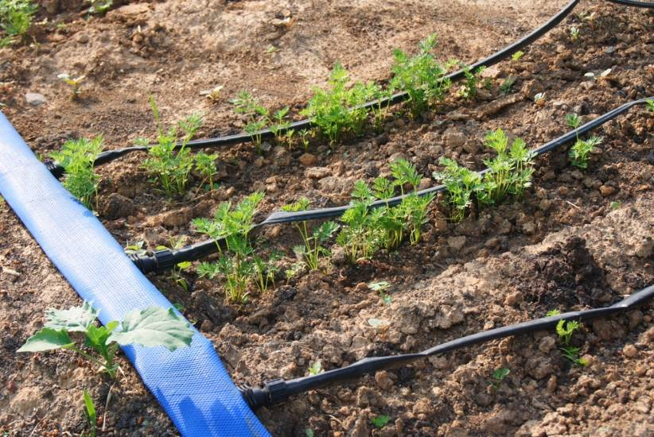  The drip irrigation system installed in private household plots | 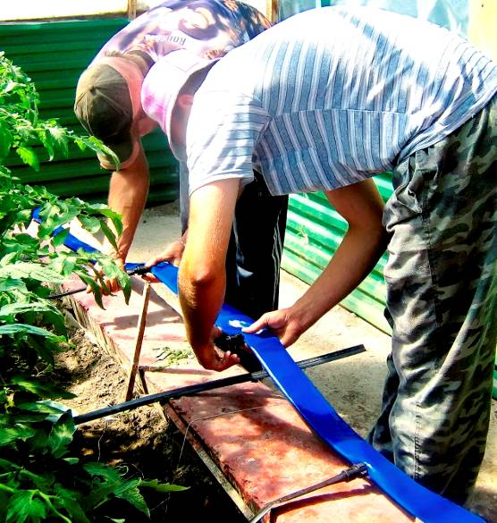  The local community members are installing the drip irrigation system

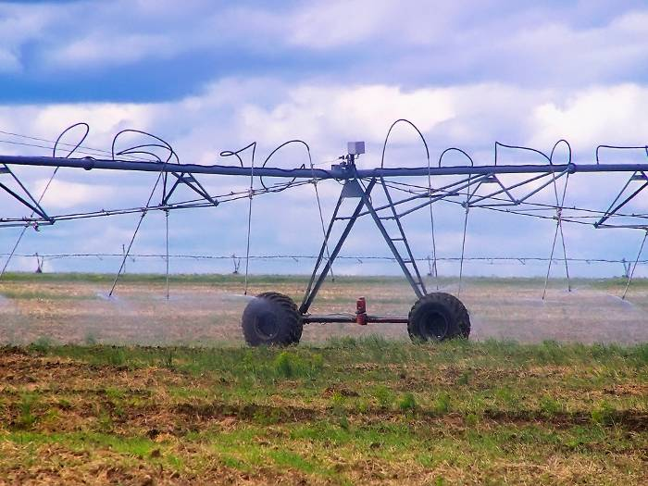  The nozzles for near-ground irrigation installed at LK Kuban irrigation units reduce water consumption and prevent soil outwash |   Winter wheat varieties

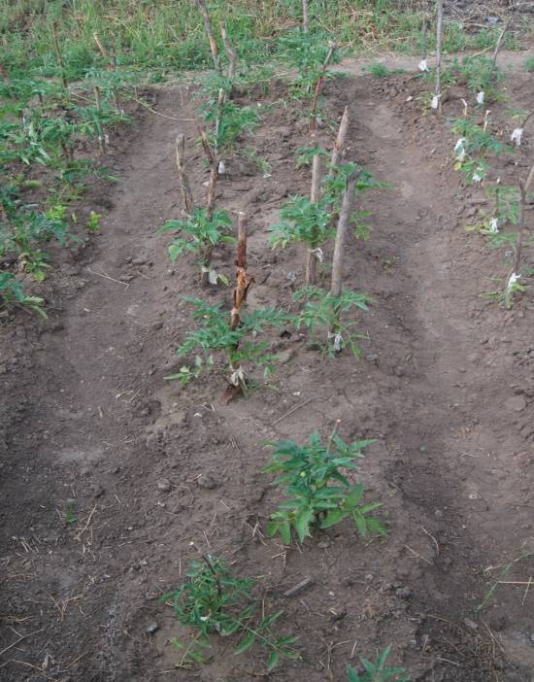  The garden without drip irrigation | 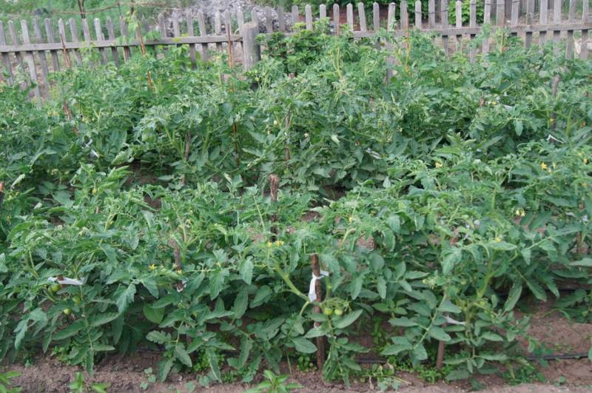  The garden equipped with the drip irrigation system

The project «Demonstration of adaptive land management under the climate change conditions (CBA/KAZ/SPA/09/11)
- By implementing the land farming system adapted to the natural landscapes and aimed at the conservation and recovery of natural soil fertility and by creating the enabling conditions for the rational use not only summer but also winter precipitation that ensure the land-use sustainability to the adverse impacts of the climate change factors, 1000 ha of land have been restored and are transferred to the sustainable management
- 1740 persons have directly benefited from the project activities
- The amount of revenues generated by the project was about 20,000 US dollars.

The project «Reducing vulnerability to declining water supplies in Burevestnik rural community (CBA/KAZ/SPA/10/01)
The project is a good example of a comprehensive implementation of soil- and water-saving technologies
- 3200 ha are under sustainable management based on the new soil- and water-saving technologies: minimal soil treatment and winter cropping of wheat under snow
- 4 dykes have been reinforced thus ensuring their serviceability in flood periods; water is saved for the technical needs of the village inhabitants; the dykes prevent soil outwash and control gully formation processes
- 1800 persons are the project beneficiaries.

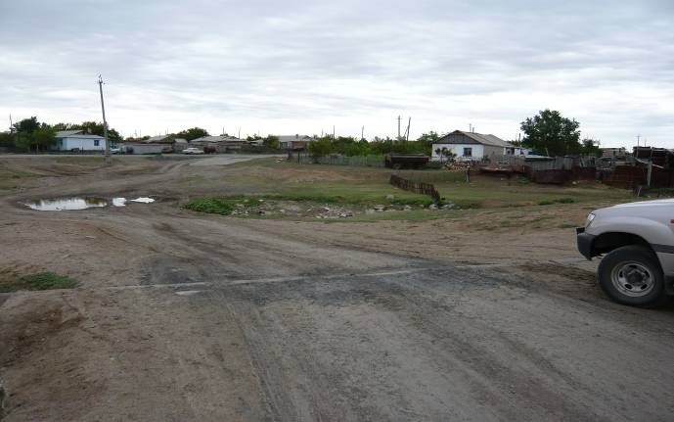  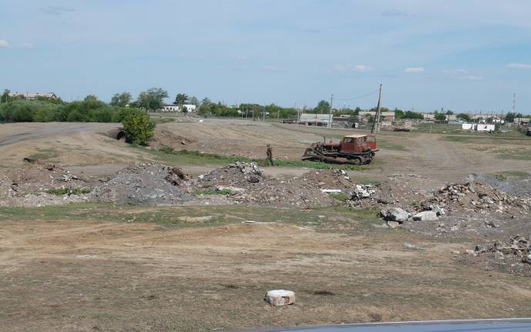  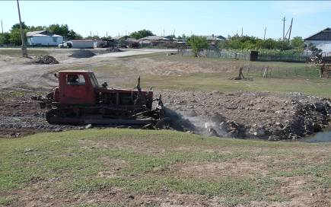  Back filling of gullies and mud-holes | 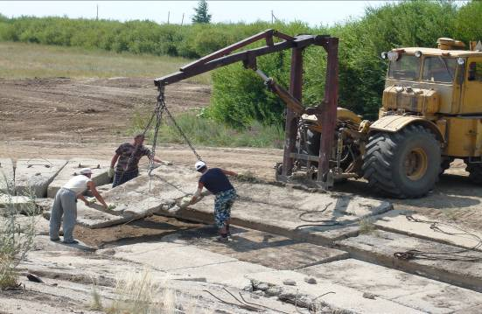  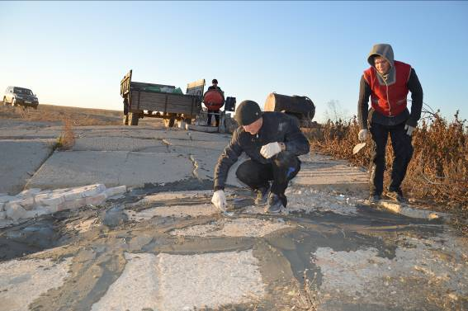

Drip irrigation installed in distant rangelands and household gardens  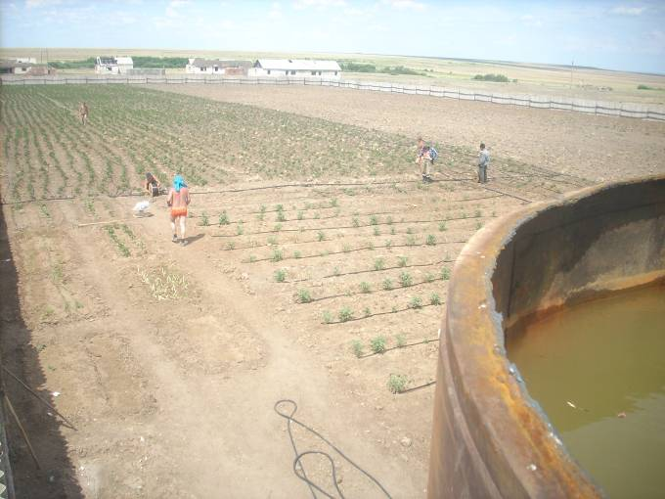  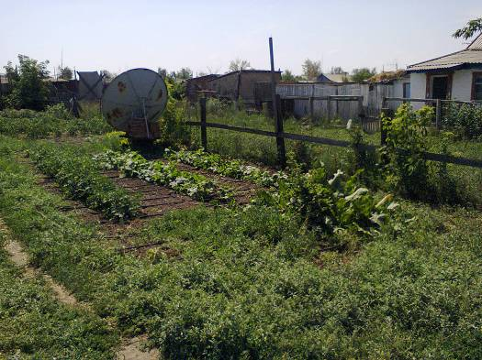  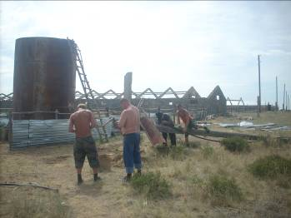 | 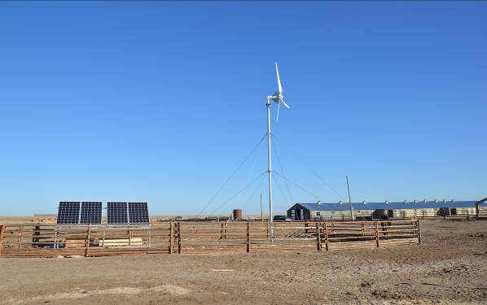  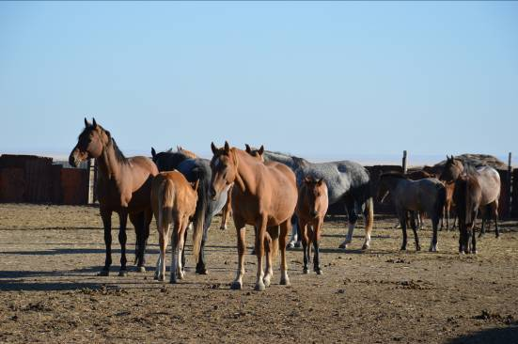

- During the project the management of Zhito LLP has approved the establishment of site for remote grazing. A vegetable field (1 ha) has been developed on the grazing site with a tank and a drip irrigation system installed to grow potato, strawberry, cucumbers and other vegetables
- The irrigation water is supplied from the well equipped with electric pump arranged by the project; a wind generator and a solar module (3 kW) are also installed
- By using the minimal soil treatment technology, 29 tons of diesel fuel were saved for 2 years of the project accounting for the local community's saving of US$19333.

The projects accomplished in the cattle-breeding area

The project «Development of forest protection belts to mitigate the climate risks connected with the reduced winter precipitation and save the soil moisture as well as to build a better micro-climate» (CBA/KAZ/SPA/09/04)
- The drip irrigation system implemented by the project (for moisture saving purposes) to irrigate the forest belts and the crops planted in the row spacing enabled to provide the plants with moisture irrespective of the level of summer precipitation, save water (2-2.5 times reduction of the irrigation cost) which deficit is already seen and will increase with the growing climate aridity and to prevent soil salinization. Owing to reduced water and electricity consumption for irrigation the local inhabitants have saved US$4164.
- Forest protection belts have been established covering 20 ha for the purposes of moisture saving, moisture retention and mitigation wind erosion risk.
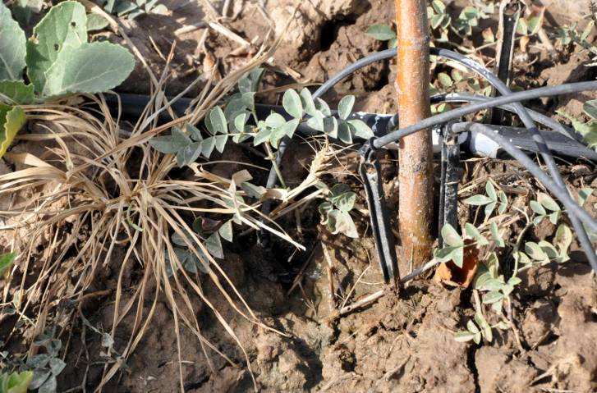  Picture 1: Drip irrigation to demonstrate efficient irrigation methods under the growing climate aridity conditions | 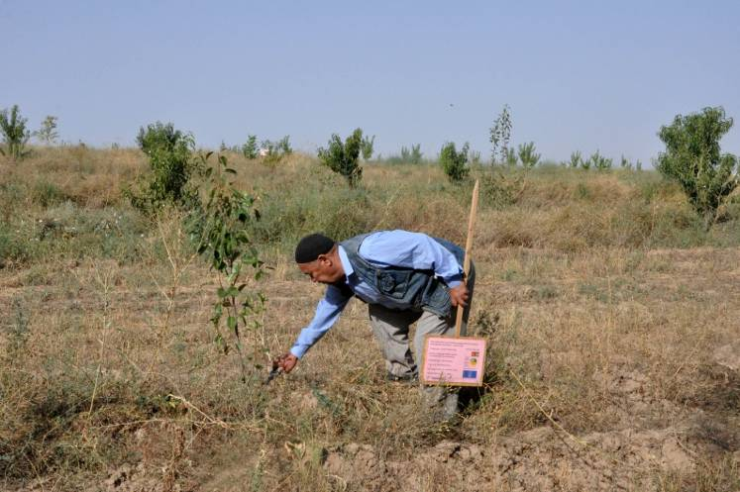  Picture. 2: Total of 11571 seedlings have been planted covering 20 ha of land with due regard of wind direction

- Owing to plantations in the row spacing of the forest belts the local inhabitants have harvested wheat (12 tons), straw (70 tons), lucerne (35 tons), cucumbers (2000 kg), watermelons and melons (8 tons) accounting for the monetary income of US$4033.
- 53 households and 30 low-income community members (pensioners, women with many children and unemployed women) have directly benefited from the project.
- 40 jobs have been created.
- 2500 persons have been informed about the project.

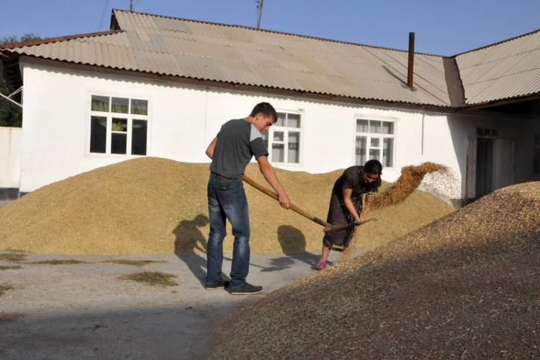 | 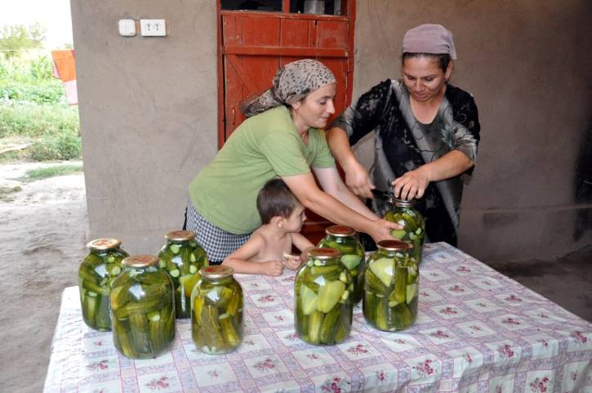
Picture 3: Wheat harvesting | Picture 4: Preserving cucumbers for winter

The project «Adaptation of pastoral cattle farming of Lepsy local community to the climate change» (CBA/KAZ/SPA/09/03)
- The distant grazing combined with the pasture rotation system enabled to put into circulation and develop sustainable management of 5850 ha.
- The grazing load on the near-village has reduced by 30-40% compared to the current loads.
- 155 households have gained benefits from the project amounting to $ 18,000

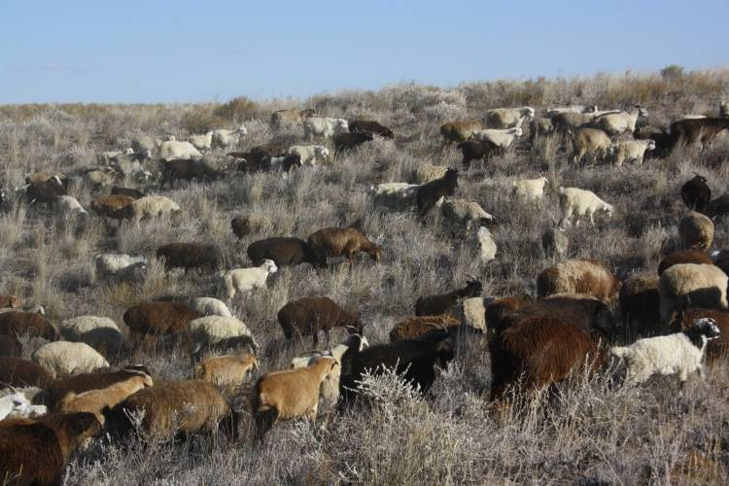  Cattle grazing on remote productive rangelands |  | 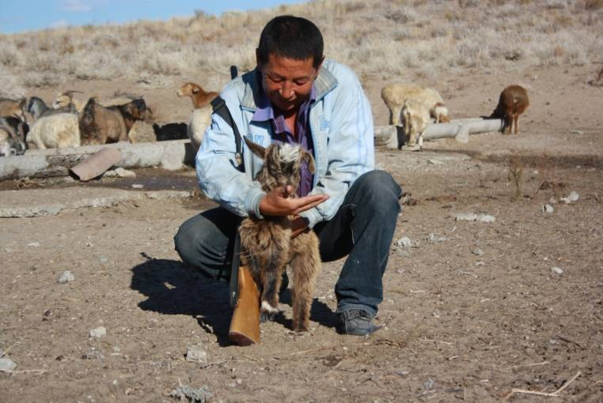
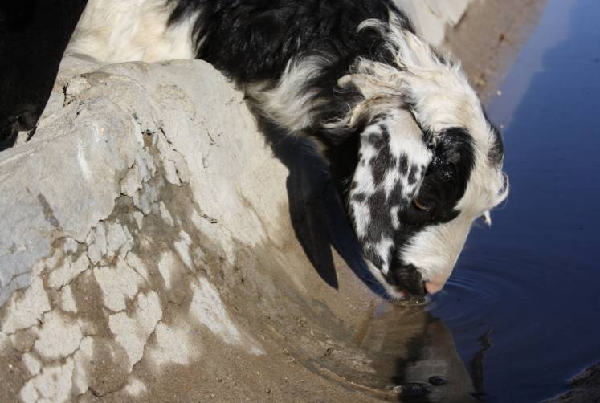  Repair of wells in the distant rangelands ensured stock watering for cattle | 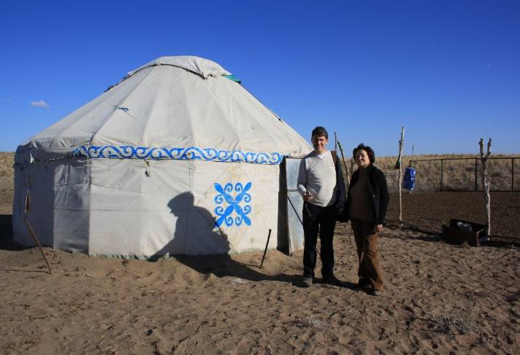  Infrastructure for herdsmen developed at the distant rangelands

The project «Autumnal/early spring fields and pastures irrigation as an adaptive mechanism for efficient use of water resources in Southern Kazakhstan (CBA/KAZ/SPA/09/06)
- Autumn/early spring irrigation of degraded lands when the irrigation water is not a deficit enabled the local community members to put in circulation and develop sustainable management of 250 ha of lands
- To grow undemanding for irrigation and draught-resistant forage and vegetable crops on degraded lands; lucerne fields cover 60 ha
- 60 tons of hay have been harvested during the project that supplied forage for 500 heads of cattle maintained in housing in winter
- 24 households have gained benefits from the project for the amount of US about $36,000.

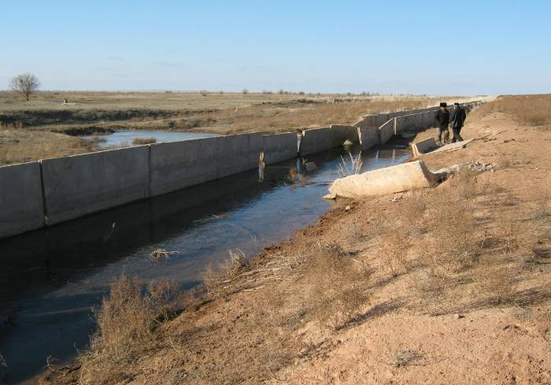  Project startup. Destroyed channel and water skipping town | 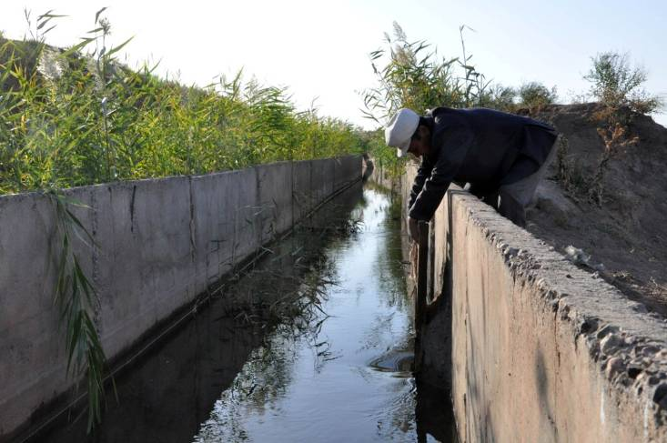  Repaired channel
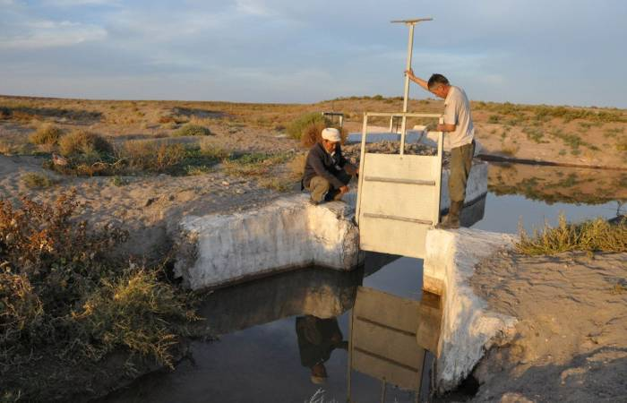  Water distribution system repaired | 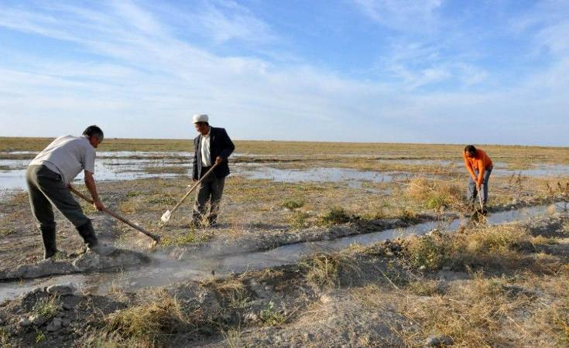  Autumn irrigation of degraded lands
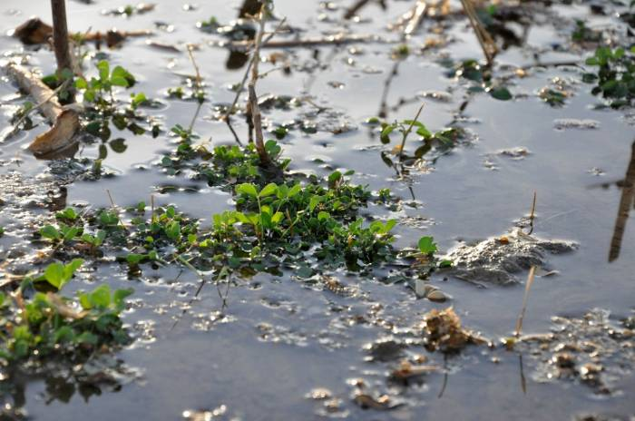  Lucerne grown on wastelands | 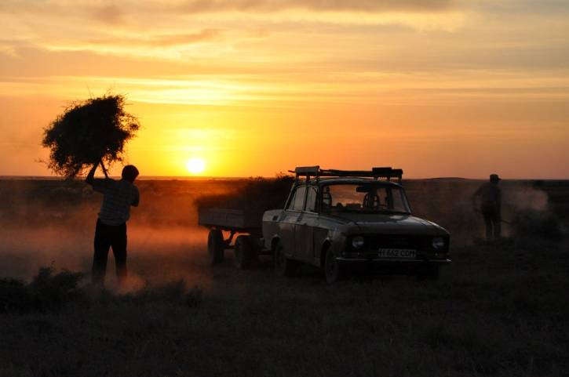  Hay making from restored lands for winter forage

From more than 30 best projects to implement the sustainable land and water saving practices reviewed on the national level, this is the only project enlisted in WOCAT list of best practices (Switzerland) and included in its global database.

The project «Sustainable land and water resources management in the arid zone of Southern Kazakhstan in terms of increased aridity» (CBA/KAZ/SPA/2011/01)
The alternative cattle breeding method (drylot goat maintenance) and strengthening of forage base due to the restoration of degraded lands and lucerne growing the load on the near-village pastures has been reduced by 15%, 200 ha of lands are sustainably managed, 100 members of the local community have gained the benefits by shifting to the new farming practices accounting for $10,666 US dollars.
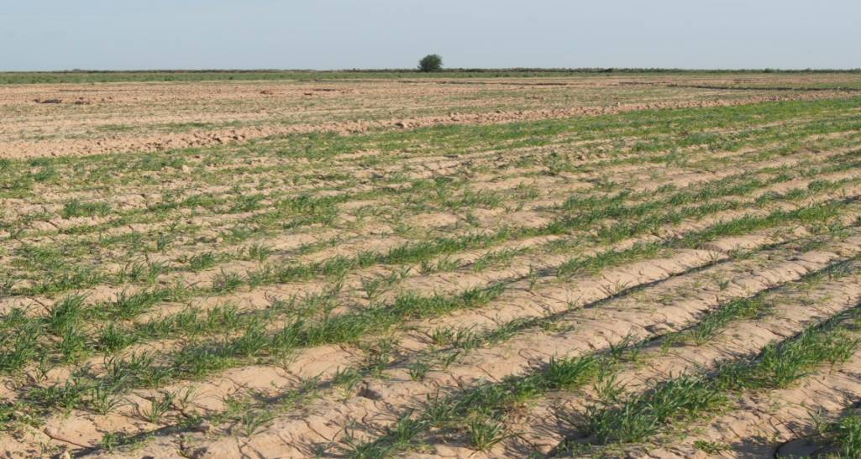
Lucerne fields

A pen for goats  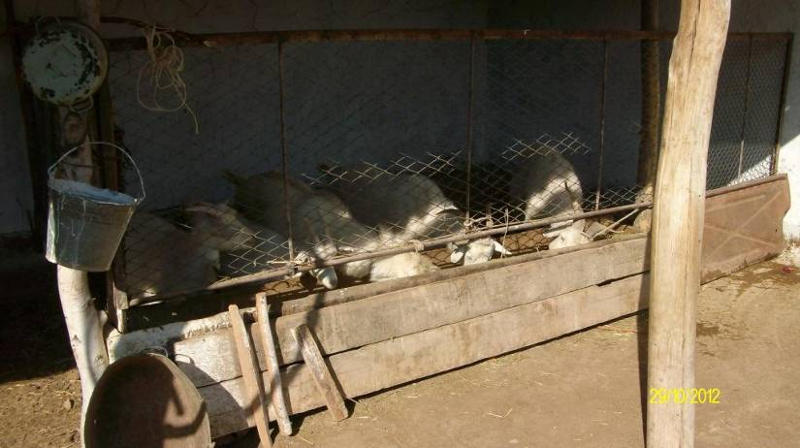 | Milk and dairy goats just bought by the LC members  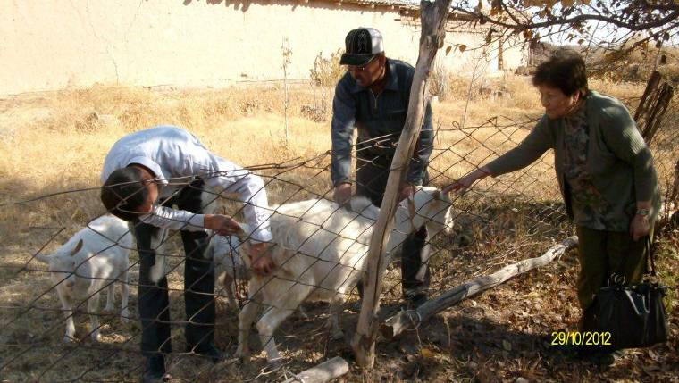

Co-financing and Partnerships

In CBA activities implemented in Kazakhstan, a great deal of attention was paid to partnership development issues and raising the additional co-financing for the project activities. Said efforts were made on both the project level by the grantees and on the Program level by SGP GEF staff.

Even at the stage of project portfolio formation and project approval, the amount of co-financing to be attracted as well as the comprehensiveness of the project approaches and the partners' willingness to invest money, labor and other resources in the project activities were one of the main criteria since in order to be able to demonstrate the efficiency of methods proposed at the end of the Program activity a strong project team is required with involvement of various partners along with sufficient financial resources apart from those allocated by GEF.

Within CBA project portfolio the co-financing resources provided on the project level have amounted to US$1,268,916 including US$772,463 in cash and US$496,453 in kind. Said amount represents the investments of the local communities and partners. It ensured the successful accomplishment of the project activities. It needs to be noted that all the projects were quite comprehensive and often connected with the new technological solutions and thus requiring the involvement of various players.

Analyzing the approaches to raising the additional co-financing and building partnerships on the project level, some aspects need to be noted in detail:
- Co-financing for most of CBA projects was ensured by the inputs of the farms willing to invest their own resources in order to implement the adaptive approaches. To this end, a great role was played by reasoning economic losses incurred by the agricultural producers applying the conventional farming practices and the opportunities to gain economic benefits with the transition to the new adaptive methods. It was equally the case for both grain production and pastoral projects. The inputs made by the farms ensured the contribution to the project activities amounting to US$583,381 i.e. 46% of total co-financing raised on the project level.
- It also needs to be noted that a great role in raising co-financing on the project level at the project implementation stage was played by the fist positive results achieved and the dynamics of mainly economic figures associated with the new adaptive methods applied. To that end, from the very beginning the project staff has been observing and recording revenues and costs for the new methods and technologies applied. Thereafter such records were actively demonstrated to the farmers and the other businesses in order to show the benefits. So, e.g., under the project implementing the nozzles for near-ground irrigation installed on 2 irrigation units, after the first year of the project activities the farmers have invested money to re-equip another 2 irrigation units with the same nozzles. Under the drip irrigation project for irrigation of large areas, the drip irrigation system for part of the irrigated land was installed at the farm's cost.
- A great role in attracting co-financing was certainly played by the demonstration of successful experiences in applying certain technologies, approaches or methods as well as specific tangible benefits gained by the local communities in connection with the project. So, e.g., the successful demonstration of drip irrigation for the household gardens in the North Kazakhstan under CBA project enabled to attract the additional co-financing in the amount of US$100.000 from Coca-Cola Company to expand the project activities and involve 5 villages.
- For one of the CBA projects, co-financing was provided from the international agency whose interests were clearly linked by the proposer with the CBA project’s interests whereby the attracted amount made US$158,000.

Taking into account the comprehensiveness of all CBA projects, their successful implementation would have been impossible without the involvement of various partners in the project activities including governmental agencies (specifically, the akims (local governors) who have been crucial in allotting the lands for the projects, especially it concerns the pastoral and distant grazing projects), farms that in many instances were the forces that ensued the sustainability of the project activities, first of all, in financial aspect, as well as the active and respected members of the local communities who were convincing and supported the other inhabitants when implementing the project and essentially played a positive role in achieving successful results.

It should be specially noted that the projects and specifically the challenges encountered by the rural communities and NGO’s in the process of implementation encouraged the consolidation of the communities and development of volunteerism on the spot.

As far as the program level concerned, co-financing was provided by the additional funds granted by the Swiss Government. Said resources have been allocated mainly to the capacity development of various focus groups in the field of adaptation (including the funds allocated to strengthen certain components of the ongoing CBA projects – 6 projects have been provided grants for the total sum of US$60,000) as well as the demonstration and dissemination of the successful experiences and promotion of the adaptive approaches to the national and regional levels.

Taking into account the limited number of donors active in Kazakhstan, the emphasis on the program level was on the development and strengthening cooperation and partnerships mainly with the organizations, programs and projects cross-disciplinary in relation to CBA activity of attracting the resources for the activities connected with sharing the experiences gained by CBA projects, promotion of adaptation methods and approaches to the national policy etc., attraction of resources for monitoring and evaluation of CBA projects. To this end, the following has been achieved:

1) Owing to continuous interaction and cooperation with the UNDP projects (in the field of land degradation, climatic risk management and capacity building of the country in the field of climate change etc.) a number of activities have been organized (round tables, training sessions for journalists and NGO's) that enabled to raise the issues of climate change and adaptation to broader discussion on the national level covering the CBA's deficit of financial resources for such activities; develop a series of publications that have included and disseminated the information of CBA projects' successful experience (specifically, through the initiative of one of the UNDP projects, CBA project of autumn and early spring irrigation has been selected as an example of the best practices and included in WOCAT database of successful projects (Switzerland)).

2) The members of partner organizations, notably, Farmer of Kazakhstan Foundation, UNDP projects have been actively involved in the monitoring of CBA projects on a free-of-charge basis.

Mainstreaming, Transitioning/Phasing in, upscaling and replication

Taking into account the indicators set by CBA Program and realizing the significance of promoting and disseminating the information about the experiences gained through CBA projects, successfully implemented approaches and methods both at the level of the project sites, country and even the entire Central Asian region, for the entire CBA program duration a great deal of attention has been paid to the efforts focused on broad awareness of CBA activities. Such activities included mainly the workshops, training, round tables and other events.

Further promotion of the results of CBA activities is seen a number of areas as described below:

CBA programme promotes its achievements at the national level via UNDP and other partnering organizations. Thank to this cooperation, National Adaptation Concept was developed, preliminary approved by the Council for Sustainable Development in 2011. Now, the National Strategy on Green economy is under development, and it’s expected that the National Adaptation Concept will be consolidated into this Strategy. In case adaptation strategies are approved by the Government in 2012 within the Green Economy Strategy, state support will be rendered to many adaptation measures.

Even now the proven methods and approaches are promoted in the framework of various partner initiatives of SGP to a number of existing national, regional and local programs. At the national level, СВА promotes adaptation measures to be supported by the government within different existed state programmes and projects (National Remote Pastures Development Programme, Green Strategy development etc.)

Taking into account a very limited donor presence in the country, possibility for additional financial support of the CBA projects is also bounded. At the same time, many partners have recently started activities on adaptation (mainly been focused on researches and outreach activities), or being involved into the activities on efficient land or water management are very interested in the experience gained within the CBA projects. They are ready to widely share (via seminars, trainings, publications etc) the CBA project approaches. And this is what they are actually doing. Often they use the project executors as lectors on particular topics for other LCs.

Some projects have already been up-scaled or distributed by other parties. Akbota project has got additional support from Coca-Cola for $100,000 for the drip irrigation system installation in 5 settlements, as it was mentioned above. Besides, this project is the most famous one among all the CBA projects, and at the moment it’s the demonstration platform close to Astana, where all the missions, journalists are coming to see the results achieved. This was achieved thank to the exceed expectations work done by NGO within the CBA project and results demonstrated.

Landscape planning project has got financial resources from the state budget of about $44,000 from the Ministry of agriculture to share the activity the CBA project started. The approaches implemented within Kogal (autumn water irrigation) and Shyrkyn project (drip irrigation and forest protection belts creation as well as plantations in the forest belts rows approaches have been started to distributed and implemented by other LCs in other settlements.

The CBA projects experience was shared in Central Asian Region (via publications, workshops, presentations etc.), and many approaches like sustainable pastures management, forest protection belts planting, drip irrigation etc. are also used as adaptive mechanisms in other CA countries.
The projects have much promoted to voluntarism movement development at the local level, which has become a very important achievement, as many people felt like a community. It’s also need to be noted that the issues of promoting CBA approaches, knowledge sharing could be possible only with partnership at all levels.

So, e.g. the two national-level round tables jointly organized with the UNDP/RK MEP project «Strengthening the capacity in the field of sustainable development through integration of climate change issues into strategic planning in the Republic of Kazakhstan» dedicated to the climate change issues with involvement of a large number of the officials from the state ministries and departments (the Ministry of Environment, the Ministry of Agriculture, the Ministry of Emergency Situations, the Ministry of Economic Development and Trade, the Ministry of Health etc.), the representatives of large-scale national companies, scientific-research institutes, UNDP projects, business sector (about 150 persons) and the training for NGO and journalists dedicated to the climate change adaptation issues (about 50 persons involved) enabled to broadly disseminate the information about SGP GEF activities within the framework of the Community-Based Adaptation Program and raise the important issues on the national level. The result of such cooperation between SGP GEF and the UNDP project was the inclusion of the CBA projects approaches as the basis for urgent adaptation measures and strategic directions within the National Concept on Adaptation to the Climate Change in Kazakhstan.

lessons learned and Challenges

Country programme strategy preparations
The main barrier to the country program strategy development was that the adaptation issues were quite new for the country and had never been reviewed in detail, especially from the perspective of the reduction of rural communities' vulnerability under the growing climate aridity conditions.
The second issue is the selection of priorities: it was necessary to identify the most vulnerable sector in terms of climatic risks. Taking into account the large territory of Kazakhstan and a great difference in the natural climatic zones it was necessary to select the most risky regions in terms of the climate impact. The work should have been structure in a way that cumulative effect could be gained and the focus could be kept. It was quite difficult to achieve, a lot of time was spent for consultations with expert and search of materials etc.
Another challenge was to obtain the analysis of climate change trends as of the last decades.

Project formulation and development,
The main challenge here was to make the rural communities understand the issues of climate change and adaptation. It took a great deal of efforts in the form of consultations, workshops, and training to achieve this.
Another issue was the project format different from SGP format that required the search of measures that would really be adaptive in addition to achieving the global environmental benefits and improvement of living conditions of rural inhabitants. To that end, the additional training and involvement of experts was necessary for the preliminary formulation of the project proposals.

Project monitoring and evaluation
Taking into account the lack of communities' experience in implementing the adaptation projects (as mentioned above) as well as the comprehensive nature of the proposed approaches, continuous monitoring of the project progress was required to ensure the projects' positive outcomes. That was rather time-consuming for SGP GEF staff members; the visits to most of the project sites associated with the adaptation projects were paid 3-4, sometimes 5 times a year. The same was true for the involvement of experts. Taking into account the long distance of the project sites from SGP GEF office (the nearest project site was 470 km from Almaty), it took plenty of time and financial resources. Therefore, normally, the monitoring visits to CBA projects were combined with the monitoring of SGP GEF projects thus enabling to use a more strategic approach to spending the limited CBA resources.
In addition, the practice such as involvement of UNDP project staff members in the monitoring of CBA projects was used in the framework of their full-time work on capacity building and development of local communities.

Community mobilization and social inclusion
Taking into account the specific features of society building in soviet times where most of the issues pertaining to the social-economic development were the government's responsibility, and taking into account the challenges of the reconstruction period where the old system was fully destroyed and a new every-man-for-himself approach has emerged, the rural communities formed today are not inherently willing to address the existing problems on a joint-effort basis. To this end, at the initial stage the challenge was to consolidate people for the joint implementation of a certain initiative. As a rule, everything was relying on a strong leader and a small support team. And only at the stage of positive results achieved people were more active in implementing the joint efforts.

Working with individual volunteers and/org volunteer groups, implementation of the methodology on Volunteers in Community-based Adaptation to Climate Change

It needs to be noted that the spirit of volunteerism in Kazakhstan is rather low as compared to volunteer movements in the other developing and industrial countries. This is determined by historic peculiarities of the country development in soviet times where the spirit of passiveness and dependency was fostered. Though historically Kazakhs had a notion of asar method where the community members helped one another in addressing common problems. It needs to be noted that in many instances the aggravation of environmental situation and social-economic standing seen in the recent years as well as the joint implementation of the project activities promoted the understanding of volunteerism.

Training and capacity building, including training on the methodology on Volunteers in Community-based Adaptation to Climate Change
The program implementation at all stages required a great deal of training and awareness efforts, again due to low understanding on the part of the local communities of adaptation and climate change.

Partnerships and their mobilization into project processes
Partnership development is a crucial term for successful project implementation.

Knowledge codification and management,
The results and achievements of each project were carefully collected through the entire project duration and have finally been compiled in the final publications that presented the environmental and social-economic data. It should be emphasized that those were the environmental benefits that in many instances served a reason that enabled to advocate successfully the approach tested.
All the publications associated with the projects have been prepared and made in a unified format and style in order to create a single brand and become recognizable. The materials presented contained the data of economic benefits of the approaches tested since it is the economic benefit that becomes an impetus for many people to start applying new methods and approaches.

Influence of policy at all levels
All the projects worked in tight cooperation with the local authorities involving them in the project activities. In many projects the work was impossible without approval of principal aspects by akimats and various state departments of the local level. Specifically, in many instances in pastoral projects it was necessary to obtain the approvals from akimat for land allotment as well as the issues of grazing and grazing pattern. To this end, due to the project activities the changes have been made to the land use model.
Owing to the close collaboration with UNDP, the issues of adaptation were promoted to the national level to be discussed by the decision-makers.

CBA contribution in the preparations of follow up national stand alone projects funded by GEF and adaptation fund boards
Directly CBA implementation has not resulted in the development of any stand-alone GEF project in the given area, but the approaches that have been tested by the adaptation projects and the experiences gained made the basis for the potential activities of the projects being now under development, specifically, the project on Aral Area. Said approaches and experiences start being implemented in the other parts of Kazakhstan, specifically in Kyzylorda and Semipalatinsk oblasts. As a follow up of the CBA activity in the grain production UNDP USAID project has recently started operations.

other important reporting

- Relevance:
It needs to be noted that at the outset of the Strategy development and the CBA project portfolio formation, the priorities and areas of activities were determined based on the following two aspects: 1) the program needed to cover the most vulnerable sectors from the standpoint of the climate change trends; and 2) the CBA program activities needed be linked to the existing country programs and plans both in the field of environmental protection and social-economic development of Kazakhstan. A large number of consultations and meetings that have been arranged with various expert groups at the initial stage of the Program development enabled to ensure the implementation of the above-set objectives and focus on the agricultural sector as the most vulnerable in terms of climate change and its two main areas: grain production and cattle breeding being also the priority areas of the country development and ensuring its economic stability.

- Effectiveness &Efficiency:
Analyzing the efficiency of CBA program and the achievement of the outcomes set, it needs to be noted that all of them have been fully accomplished. Owing to the successful pilot initiatives it has been demonstrated that the local-level adaptation is not only possible but also can be successfully implemented through the local community efforts and the issue of adaptation to the climate change is not extraneous for the local community's understanding. We may positively state that CBA Program was the first country initiative that has raised the issues of practical adaptation. It was the CBA Program that has built the basis for the first pilots that through the successful implementation of various approaches have laid the foundation for subsequent replication of the adaptation measures at the local, national and even regional levels. The first experience of CBA projects made the basis of the National Climate Change Adaptation Concept (2010) and nowadays the approaches implemented within CBA Program are promoted through the Green Economy Development Strategy, the Law of Pastures etc.

CBA Program has made a practical contribution to the existing programs, made a practical basis for those standards and codes that exist in the country.

- Sustainability:
- First of all, it needs to be noted that CBA implementation and ensuring the sustainable outcomes required huge efforts from both the grantees and the CBA Program staff members. No one has ever dealt with the practical adaptation and no one could give ready answers to the question of how the things need to be arranged. CBA Program was facing a demanding task i.e. to gain a tangible positive result within the limited time (that could have been ensured only with the right approach to selecting the methods and practices that should have been ‘environmentally gratifying’ and cost efficient) and promote the experiences gained to the operating national programs for subsequent replication. It was necessary to select a good project team willing to invest their time and resources to build partnership on the spot, raise additional funds often to the brand new and unproven methods and ensure guaranteed results.
Regarding the sustainability, the significance of the approach sustainability in respect of each individual project needs to be specifically mentioned that was ensued by the fact that each individual CBA pilot initiative was building the mechanism of sustainable functioning and development both in terms of attaining an environmental effect (reduction of the land degradation process), reducing the vulnerability of ecosystems to the climate change (adaptation component), and in terms of community sustainable development under the climate change conditions. The above tasks have been accomplished successfully.
In addition, an important notion is that the small pilots have made the basis for the large-scale changes at the national level and grew into broader initiatives (USAID/UNDP project on adaptation in the field of grain production, 2012-2014) that enabled them to be disseminated further and develop at a higher level and in broader scale. The National Climate Change Adaptation Concept, the Strategy of Transition to Green Economy, Zhasyl Damy Industry Program, the Law on Pastures, the National Action Plan to Combat Desertification and the National Biodiversity Action Plan, the work plans of akimats are the mechanisms by which the successfully tested adaptation approaches could be followed up at the national level and ensure the sustainable development using the resources available in the country.

- Impact:
One of the perfect examples of the successful adaption experience may be the project «Adaptation of farmers’ agricultural practices in response to intensified climate aridization in Akmola Oblast» (CBA/KAZ/SPA/09/01). Said initiative is a standard-bearer of the successful pilot CBA initiatives implemented in Kazakhstan. First of all, it needs to be noted that the approaches proposed within the project are pretty simple and thus are well understood by the local inhabitants and are easily replicated. Specifically, the drip irrigation system implemented in the household gardens is a great adaptation mechanism enabling not only to spend water efficiently given the limited access to water resources, but also to develop in a sustainable manner under the growing climate aridity conditions. For the time being, the project is functioning fully on a self-sustainable basis. Owing to the successful implementation and demonstration of the positive results the project has been replicated in 5 villages of the same district under financial support provided by Coca-Cola Company. To date, the project has been replicated in Uzbekistan and the approach is actively adopted by the local communities in different areas of Kazakhstan.
The results attained by the project cover practically half of the performance data under CBA key outcomes (please refer also to Outcomes& impacts).
This is just a wonderful example of the community spirit and volunteerism development through the community involvement in the implementation of adaptation approaches (primarily it concerns young people and women).
Further development of the approaches tested by the project will be followed up by the UNDP/USAID project on adaptation to the climate change in the grain-production area of Kazakhstan launched in 2012.

SPA CBA PRODOC OUTCOMES
Outcome 1. Enhanced adaptive capacity allows communities to reduce their vulnerability to adverse impacts of climate risks from both incremental and discrete events

All the project activities executed under CBA Program have been focused primarily on implementing the methods and approaches that encourage the vulnerability reduction and sustainability improvement of the local communities and ecosystems to the climate change risks, mainly those connected with the growing climate aridity aggravating the land degradation processes and reduction of access to water resources. That was the intent to form the project portfolio and the main focus to organize and implement a set of activities on awareness raising and capacity building.

Analyzing the project portfolio it needs to be noted that all the activities are of adaptation nature and are focused on the growing climate aridity. The approaches and methods applied are not extraneous, instead they combine the brand new (though easy-to-understand) methods and traditional knowledge that, taken together, enable the local communities to implement them successfully and adapt under the increasing climate aridity. Those include the drip irrigation system (3 different approaches) as the method ensuring efficient water consumption given the limited access to water resources and enabling the local communities to practice their farming activities in a sustainable manner regardless of the climate changeability and its changes in the long term; the development of more productive distant pastures and implementation of pasture rotation in view of their moisture content, improvement of the forage base through putting into circulation the degraded and waste lands and planting draught-resistant crops, development of inundable meadows (the use of flood waters and seasonable overflows) as the methods to improve the productivity of cattle farming and ensure stable income to the local communities irrespective of the climate changes and restore and sustainably use the degraded lands which conditions also determine the community livelihoods; the transition to the new soil treatment practices (minimal soil treatment), implementation of the adaptation cropping methods (planting draught-resistant and frost-resistant varieties, cropping in view of the moisture content of the fields, planting seeds under snow), implementation of efficient irrigation methods (spray method and sprinkling method based on the near-ground sprinkling nozzles) that ensure to reduce considerably the cost of water consumption, getting high crop yields irrespective of the external climatic factors.

As a whole, within the entire CBA project portfolio 13 adaptation methodologies have been implemented and successfully tested that enabled the local communities to become more sustainable to frequent draughts, reduction of precipitation, intensified dry hot winds and the other climate risks.

Specifically, application of water-charging irrigation (the project «Autumnal/early spring fields and pastures irrigation as an adaptive mechanism for efficient use of water resources in Southern Kazakhstan» CBA/KAZ/SPA/09/06) is a good adaptation practice for the local communities in the areas where land farming has been previously developed though nowadays due to the growing climate aridity water resources are in deficit and the land degradation processes are progressing. The use of water for autumn irrigation when water is not a deficit enabled the local community to irrigate their fields and pastures free of charge in the quantity required thus restoring the natural grass cover of degraded lands and increasing the pastoral productivity by 20-30% and creating the forage base (lucerne plantations) for the cattle. Water diversion in autumn enables to feed the soil, replenish the deficit of winter precipitation and enlarge the period of moisture accumulation within the root-formation soil layer since melting of frozen water takes approximately the same time as snow melting. Despite the fact that the recent several years have been excessively dry, the local community members develop sustainably and irrigate their fields using the same method of autumnal/spring irrigation thus expanding the area of irrigated lands and restoring them gaining stable revenues that ensure sustainable livelihood.

VRA results clearly demonstrate the progress achieved by CBA projects in the field of LC vulnerability reduction to the climate change. The workshop participants have been asked 4 indicator questions as listed below:
- How serious is the current impact of the climate change on you livelihood?
- Where the unfavorable years become normal, how serious will it influence your livelihood if the current agricultural practices are used?
- How serious are the barriers towards using the new adaptive agricultural method?
- How confident is the community in the reduction of their vulnerability to the climate change risks owing to the project adaptation activities implemented?

The scores have been assigned by the workshop participants based on a 5-grade scale where 5 corresponds to high impact, confidence and 0 – low impact, lack of confidence.

The results of vulnerability reduction assessment in respect to the local community members to the climate change risks performed at the beginning, in the mid-term and at the end of the project have shown a considerable growth of interest of the village inhabitants in the project activities. Where at the beginning of the project the majority of local community members had doubts about their capabilities and the attainment of positive results (for some projects, the score was as little as 1.2), at the final stage the situation has fully changed; people have become confident. The local community members have noted that the project outcomes achieved demonstrate the capability of adapting to the growing climate aridity in future (in some cases up to 5).

Indicator 1. Both at the initial stage of the project and the mid-term and final stages, in most of the projects the local inhabitants have noted numerous examples of the ongoing climate change at the project site, observations of air temperature elevation for many years, reduction of spring and summer precipitation i.e. the growing climate aridity. Therefore, at the workshops the scores assigned by the participants were rather high (4,0-4,7) showing high impact of the climate change on the livelihoods of the local community members. Although in some projects the data under Indicator 1 in the beginning and mid-term of the project were low (in some cases reached 1.07, 2.9, 3.1) that is explained by the local community members by the positive impact of the project activities and the results gained by the projects.

Indicator 2. The impact of further growth of unfavorable climate change trends was ranked high by the local communities in most cases at the initial stage (ranging between 4,5-5.0 on average), while in the middle of the project and at the final stages the scores assigned were lower (0.93, 3.0. 3.2). The comparison of such assessments shows some reduction of the climate impact on the livelihoods of local communities. Such trends, however, are connected with the project activities. According to the workshop participants, the project results already gained and those expected give them confidence in the adaptation to the growing climate aridity expected in future.

Indicator 3. The main trend here is similar to the first two: at the beginning of the project th elocal communities were not be confident in their capabilities to remove the barriers constraining to their implementation of the adaptive methods (3.7 – 4.6). As the projects progressed, the trend has been changing owing to the adaptive methods implemented and the first positive results gained. (2.44, 4.0). The assessment provided by the local inhabitants shows that the project has helped to remove a large number of constraints at the local level.

Indicator 4. This is the most illustrative indicator to assess the impact of the project activities. The assessment has been changed maximally as a result of the project activities. At the initial stage the local communities assigned the lowest scores (1.2, 2,8) showing practically complete lack of confidence in their abilities to meet the project objectives. At the second VRA workshop the participants have assigned higher scores (3-3.8, in some cases 4.8-4.9) to their capabilities and willingness to proceed with the project activities at the end of financing. It is quite understandable since the funds received from CBA and the works accomplished have stimulated the inhabitants' interest and their willingness to actively implement the practices. The increased scores have shown the confidence of the project participants in their capabilities and the willingness to follow up with the project at their own cost.

Essentially such analysis is the most objective since the local community members assess the efficiency of the project works. In addition, it clearly reflects how the project activity contributes to the vulnerability reduction of the communities to the climate changes. The positive result was also the increased commitment of village inhabitants and encouragement of volunteerism. People have seen that they need to change water and land resources management system at the local level and this can be achieved only through the joint efforts.

14 methods have been implemented within CBA projects focused on the mitigation of climate change risks; 13 approaches to the natural resources sustainable management have been tested to improve the livelihood of local inhabitants and protect the resources; 10 rules adopted by the project have been implemented; the area transferred under sustainable water and land resources management has covered about 20,000 ha; over 500 households have benefited from the activities on natural resources sustainable management.

Outcome 2. National policies and programmes promote replication of best practices derived from CBA projects

As was earlier stated in the report, CBA Program was the first practical initiative at the country level in the field of adaptation. That was specifically CBA Program that has enabled to gain the necessary practical experience being the basis for subsequent initiatives such as the Climate Change Adaptation Concept development (the joint work of the UNDP Project, MEP and SGP GEF) essentially built on the tested approaches of CBA projects as the recommended adaptation measures: implementation of the drip irrigation system; forest protection belts; the sustainable use of pastoral ecosystems; water-charging irrigation; inundable meadows; implementation of the landscape planning etc. That was owing to said joint initiative that the adaptation issues have first been brought to a broad coverage at the national level through a series of round tables and workshops with an active involvement of the representatives of governmental agencies, NGO's and experts accompanied by presentations of the experiences gained by CBA projects; through training sessions organized for NGO's and journalists acting in the provinces followed by the sites visits in order to present the work results gained by the local communities on the spot; through the involvement CBA Program experts in the work groups dealing with the Concept Paper drafting.

The activities of CBA projects have been reflected in the other initiatives as mentioned below which implementation will ensure the sustainability of further dissemination of the adaptation practices: the Law on Pastures and Distant Grazing Development Program, and Green Economy Development Strategy that are currently under development and will be adopted in 2013-2014. Under said initiatives the aspects of green technologies and approaches will be covered fully relating to the practices tested within CBA. CBA experts and SGP GEF NSC members at all levels take an active part in promoting the adaptation issues and sharing CBA experience with the national programs and policies: through involvement in the work groups when developing strategic documents, preparing recommendations, participating in the meetings and sessions etc.

The UNDP/USAID project on adaptation to the climate change in the grain production sector has been launched that will enable to strengthen and expand the activities commenced under CBA in the relevant sector. The project is focused on the sustainability improvement of the grain production sector in Kazakhstan to the climate conditions by maintaining the regional dialogue relating to the climate change impacts on agriculture. The project will seek to remove the threats leading to the reduction of food safety in the region. Strengthening the dialogue concerning the challenges faced by food safety in the region will encourage both political decisions to be made and strengthening political will to remove them. The project will involve the leading analysts from the governmental agencies, private sector, academic community and NGO sector. During these two years the project will implement the three components, notably: 1. Improvement of monitoring and information sharing for the production of wheat sustainable to the climate conditions (Kazakhstan); 2. Strengthening the resistance to the climate change consequences by integrating the climate change adaptation measures (Kazakhstan); 3. Providing support in the regional dialogue concerning wheat production, climate change and food safety in the region (Central Asian countries).

Nowadays CBA experience is broadly disseminated across the Central Asian region. The drip irrigation project was replicated in Uzbekistan; CBA methods and approaches were presented at 10 regional CA and 9 national workshops dedicated to adaptation and sustainable use of land and water resources. The experiences gained by CBA projects are covered within CARESD, via DRYNET that disseminate the information across the entire Central Asian region. 6 adaptation national round tables (including 3 in CA countries) and 20 workshops for NGO's and LC's in the provinces have been organized for the purposes of awareness raising and capacity building of various focus groups in the field of adaptation. To raise the awareness among a public society about the climate change and adaptation at the national level 3 special National trainings arranged for NGOs (2 trainings) and mass-media (2 trainings). The trainings have allowed acquaint the civil society and mass media with the CBA activities, as well as the strategic activities, like National Concept for adaptation development. Besides, 5 site-visits were arranged for mass-media and NGOs to demonstrate the experience gained within the CBA projects (Arnasay village, Shyrkyn village, Lepsy settlement) on drip irrigation usage, sustainable pasture management, forest protection belts planting, etc). Both trainings and site- visits have allowed to widely disseminate information about the problem, as well as the results of adaptation projects, and contributed to the production of higher quality materials on climate change and adaptation at the national level. Over the project period a series of information materials have been released. Remarkable and significant is the fact that most of the information material was produced by representatives of mass media on their own initiative.

A large amount of work was accomplished on the spot within each individual project: more than 30 training sessions and workshops along with the presentations for LC members and NGO's, akimat representatives and journalists have been conducted at the project level.

CBA projects have made a considerable contribution to the development of a practical basis for 6 national initiatives, programs and projects, both ongoing and being under development; have involved key ministries in the discussion of adaptation-related issues (the Ministry of Environmental Protection, the Ministry of Agriculture, KazNIIMOSK, KazHYDROMET, specialized academic institutions on agricultural sectors development, Majilis and Senate of the Parliament, Council for Sustainable Development etc.). Certainly it was made possible not only due to the projects themselves but also the partnership with the UNDP projects and programs, involvement of a great number of experts and NGO's, whose volunteer activities highly contributed to the results attained.
Under the project activities, the experiences have been collected and summarized in the brochures, presentations, publications detailing the data, experiences gained, analysis performed as well as the environmental and economic figures (9 publications). Said material was broadly disseminated at the national and regional workshops.

Outcome 3. Cooperation among member countries promotes innovation in adaptation to climate change including variability

At the initial stages of CBA activities it was practically a complete lack of information about the climate change adaptation problems at the national level. Within 5 years of the Program activity a lot of efforts have been made to overcome this barrier.

In the first instance, a series of awareness activities have been performed at the sites of the pilot projects; the relevant page dedicated to the adaptation program was created on SGP GEF web site that contains the information about the projects, 12 issues of the bulletin, the articles dedicated to the projects, 4 photo-stories, 7 video films, 7 publications presenting the experiences gained by each project and analysis of the results of the entire project portfolio.

Through CBA work more than 100,000 people across Kazakhstan have been made aware of the approaches implemented by CBA projects.

A great deal of work has been performed also on the regional level. The information materials on adaptation to the climate change have been prepared and disseminated. The extensive awareness activities performed have enabled to build initial basis for understanding the potential impact of climate change on Kazakhstan's development. Without the adequate awareness support the pilot project would never have been successful since it is impossible to expect initiatives and understanding with the lack of primary information.

Round tables conducted in June 2011 in Kyrgyzstan, Uzbekistan and Tajikistan enhance regional knowledge about climate change and adaptation responses based on Kazakhstan’s experience. These activities also contribute to expansion of the implemented CBA approaches over the region helping communities deal with land degradation and decreased water availability. Knowledge management and outreach activities implemented at the local and national level helps to ensure that experiences from existing CBA projects are widely shared with key stakeholders, enhancing the project’s overall local and national impact.

The Regional Round table will be arranged in Almaty, Kazakhstan, involving multiple Central Asian countries, to exchange information about adaptation problems within the region and to ensure that the lessons learned and experiences gained both locally and nationally in Kazakhstan are transferred to other countries in the region facing similar climate change threats.

Publication about adaptation and CBA based on Kazakhstan experience in Russin (Kyrgyz, Uzbek, and Tajik) were issued and disseminated to share adaptation practices and the lessons leant by CBA in Kazakhstan, as well as practices implemented in other countries. National policies and programmes, along with cooperation amongst countries, promote replication and innovation of best practices derived from CBA projects focused on land degradation and water availability, in Kazakhstan and Central Asia.

Representatives of local communities that have implemented CBA projects take part on a regular basis in various activities at both the national and regional level making their contribution to partnership promotion and experience sharing.

Reporting
As it was mentioned above, since the CBA started its activity, projects progress and achievements, as well as the entire Programme progress was presenting to different partners at a variety of events. And the reporting all the time was based on the GEB and VRA indicators laid in the country strategy.

The main focus was made on the economic impact (income generated, comparison in efficiency of adaptation and customary approaches in number (savings, advantages etc.), number of LC members benefitted etc. These were the most demonstrative figures which present the real situation and make clear the necessity to implement the adaptation activities, especially for private farming sector, governmental officials , donors etc.

