

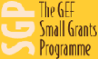
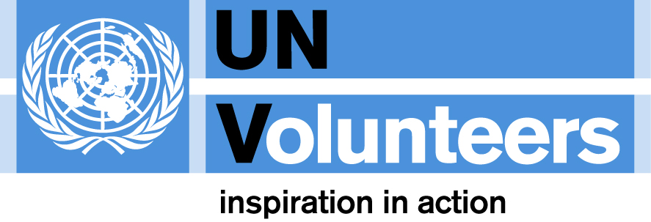
CBA operational changes
UNDP-GEF-UNV CBA Mid-Course Workshop,
July 2, 2009, Kingston, Jamaica

Detailed operational guidance for the CBA project is outlined in GEF Council Approved Project Document. Based on lessons learned during the operationalization of this project in the period from 2008-2009, the following operational adjustments are recommended to make CBA projects more country driven and more closely integrated into regular GEF SGP operational modalities.

As per the Council approved project document,
- Projects must continue to meet GEF SPA eligibility criteria (i.e. global environmental benefits and adaptation benefits).
- Project should continue to be community based with promotion of volunteerism as well as gender equality.
- SPA funds cannot be used to fund “baseline” development outcomes.
- Projects linked to other ongoing initiatives financed by government, UNDP and other agencies, NGOs, etc are recommended. Support will be provided by UNDP EEG to establish required linkages, if needed
- NSC/NCCs are encouraged to seek projects that are not “islands” of good/sound projects but strategic and catalytic ones with potential for learning and demonstration of how adaptation to long-term climate change can be pursued.

Co-financing policy
- 1 to 1 cash co-financing at the project level is not necessarily required. NSC/NCC should take into account level of in-kind/cash (direct and parallel) co-financing achieved at the country portfolio level, as well as other eligibility criteria, and decide on soundness of project. Standard SGP co-financing policies will apply. In-kind co-financing remains to be required.
- Bear in mind different sources of co-financing (direct, parallel and cash). All are legitimate forms of co-financing. Parallel financing is encouraged and is a legitimate form of cash co-financing. Letters of partnership/commitment/co-financing are necessary. The log-frame of the project should also indicate relevant details that demonstrate linkages to other initiatives claimed as sources of parallel co-financing.
- The CBA PMU and UNDP/EEG will complement local efforts to raise cash co-financing at the global level. Funds will be sought from bilateral and other sources.

Project approvals policy
- NCs and members of NCC/NSC have been, and will continue to be, capacitated to support CBA based on UNDP/EEG best practices. CBA PMU will provide support with this, upon request.
- NCC/NSCs capacitated and responsible for project screening and approval. The NCC/NSC will screen and clear projects based on standard substantive quality/feasibility GEF SGP (technical and financial) criteria as well as GEF/SPA eligibility (technical and financial) criteria. NCs will facilitate this process.
- There will no longer be technical and financial clearance from CBA PMU.
- The CBA PMU will provide demand-driven technical support and guidance to NCCs/NCs , as requested. This includes support for refining country strategies and/or project ideas/concepts/ proposals, making linkages with other relevant in-country initiatives (e.g. potential co-financing opportunities), promoting volunteerism and community participation, as well as support during implementation of projects (on VRA and other M&E). Services will be provided upon request. Available services will be developed (in consultation with NCs), and shared with the NC/NSCs by mid-July.
- The CBA PMU will undertake periodic quarterly reviews of each country portfolio that has been approved by the NCC/NSC. The review will be in terms of technical and financial content, portfolio balance, thematic scope, etc. Regular reports will be prepared for HQ and shared with external donors and other interested parties.

Organization setup
- UNDP/EEG/GEF is the overall Task Manager for the project.
- SGP (Global Manager) will be main focal point for any institutional issues pertaining to NCs and the CBA projects as per standard SGP operational modalities. Any institutional issues identified by the CBA PMU will be communicated to the CPMT. Prior in-country solving is encouraged. The CBA PMU will support the SGP/CPMT to resolve pending institutional issues.
- CBA PMU will continue to provide demand-driven technical guidance to NCs and NSCs/NCCs, keeping CPMT informed.
- CBA will be incorporated into the PRAs for all NCs. NCs do not report to the CBA PMU.
- UNV volunteers will be integrated into the project and provide all necessary support per their TORs, under the direction of the NC. CBA PMU will provide guidance and additional support to UNV volunteer as necessary.

Project Delivery
- The target is for community grants to be programmed by February 2011. Frontloading programming in 2009 and early 2010 will help the project achieve operational closure in February 2013. Financial closure will be in February 2014.

Allocations
- Resource allocations will be based on country equity and absorptive capacity considerations. By mid-2010, decisions will be made about reallocating funds if it looks unlikely that funds will be spent in one or more of the 10 countries.

Capacity Building Grants
- Per SGP’s normal procedures, 5% of overall grant making can go for capacity building grants.

Country Operating Budgets
- CBA PMU to receive estimates from each NC of COBs for the remainder of the project (preferably by year depending on anticipated delivery targets). COB requests should be sufficient to cover all needs required to implement that rest of the country portfolio, including any resource needed for UNVs to support implementation on the ground. These will be discussed, together with input from CPMT, and final COB allocations will be made.

Adaptive management practices will be exercised throughout the implementation of the project. The refinements to the operational modality of the CBA outlined above will be reviewed overtime by the CBA PMU in consultation with NCs, the SGP/CPMT, and UNDP/EEG and further changes may be made.

Notes ? Guidance on Co-Financing. - Co-financing can include resources for both: - baseline or foundational activities upon which the project would build or without which the project could not be implemented and/or - climate change risk management; - Co-financing can be from: - GEF Implementing Agency (UNDP TRAC, Bilateral etc) - Government co-finance (counterpart commitments) e.g., Contributions mobilized from other - NGOs, the private sector, and beneficiaries. 3. Co-financing can be at least three types: - Direct Co-Financing (sometimes referred to as “cash co-financing”)-- funds provided to the project and managed by the project team (usually UNDP) - Parallel Co-Financing— (usually cash financing) - funds not managed by project team or UNDP. Some other entity does this. - In Kind Co-financing – usually not in the thousands/millions! When co-financing is mobilized, (i) need to make linkages in project design/log-frame and (ii) there is a need supporting evidence.

